

MULT 25-604 – Aerial Precision: 3D Reality Capture and GIS Integration with Drone Technology

**Final Design Report**

Prepared for

Matt Merrill

GeoDecisions

By

Adil Adil

Grady Beck

Colin Drake

Nathan Germain

Under the supervision of

Tamer Nadeem, PhD and Yuichi Motai, PhD

May 6, 2025

**Executive Summary**

This document provides a definition of the scope, work, and deliverables for the Aerial Precision project sponsored by GeoDecisions and commissioned by Virginia Commonwealth University to use photogrammetry and LiDAR data to create a viewable map product that may be used by the company to make informed decisions and aid in the development process. Herein are the methods by which the project shall be completed and the limitations that have so far been identified that may limit the design process, and the alternatives that may be used to circumvent those constraints. The problem statement provides a detailed overview of the project, including background information necessary to understand the project’s goals and the process to meet its requirements. The following section presents the design requirements, including the goals and objectives, and then identifies specifications and constraints that will help narrow the feasible design options. Relevant codes and standards crucial to the project's execution are also detailed. The document then defines the scope of work throughout the project lifecycle, outlining the deliverables that will be provided to the sponsor, key milestones to ensure the project stays on schedule, and the resources needed to meet these deliverables. Overall, this document is a jumping-off point to provide the sponsor with a clear definition of what is intended by the project team and what may be expected of the project.

**Table of Contents**

Section A. Problem Statement

Section B. Engineering Design Requirements

B.1 Project Goals (i.e. Client Needs)

B.2 Design Objectives

B.3 Design Specifications and Constraints

B.4 Codes and Standards

Section C. Scope of Work

C.1 Deliverables

C.2 Milestones

C.3 Resources

[Section D. Concept Generation](https://docs.google.com/document/d/1LU_nBmXi-mb4TdqjBbfkOTWrFTcb8d91OZvPEPezje4/edit#heading=h.35nkun2)

[Section E. Concept Evaluation and Selection](https://docs.google.com/document/d/1LU_nBmXi-mb4TdqjBbfkOTWrFTcb8d91OZvPEPezje4/edit#heading=h.1ksv4uv)

[Section F. Design Methodology](https://docs.google.com/document/d/1LU_nBmXi-mb4TdqjBbfkOTWrFTcb8d91OZvPEPezje4/edit#heading=h.44sinio)

[F.1 Computational Methods](https://docs.google.com/document/d/1LU_nBmXi-mb4TdqjBbfkOTWrFTcb8d91OZvPEPezje4/edit#heading=h.2jxsxqh)

[F.2 Experimental Methods](https://docs.google.com/document/d/1LU_nBmXi-mb4TdqjBbfkOTWrFTcb8d91OZvPEPezje4/edit#heading=h.z337ya)

[F.5 Validation Procedure](https://docs.google.com/document/d/1LU_nBmXi-mb4TdqjBbfkOTWrFTcb8d91OZvPEPezje4/edit#heading=h.3j2qqm3)

[Section G. Results and Design Details](https://docs.google.com/document/d/1LU_nBmXi-mb4TdqjBbfkOTWrFTcb8d91OZvPEPezje4/edit#heading=h.1y810tw)

[G.1 Modeling Results](https://docs.google.com/document/d/1LU_nBmXi-mb4TdqjBbfkOTWrFTcb8d91OZvPEPezje4/edit#heading=h.4i7ojhp)

[G.2 Experimental Results](https://docs.google.com/document/d/1LU_nBmXi-mb4TdqjBbfkOTWrFTcb8d91OZvPEPezje4/edit#heading=h.2xcytpi)

[G.3 Prototyping and Testing Results](https://docs.google.com/document/d/1LU_nBmXi-mb4TdqjBbfkOTWrFTcb8d91OZvPEPezje4/edit#heading=h.1ci93xb)

[G.4. Final Design Details/Specifications](https://docs.google.com/document/d/1LU_nBmXi-mb4TdqjBbfkOTWrFTcb8d91OZvPEPezje4/edit#heading=h.3whwml4)

[Section H. Societal Impacts of Design](https://docs.google.com/document/d/1LU_nBmXi-mb4TdqjBbfkOTWrFTcb8d91OZvPEPezje4/edit#heading=h.2bn6wsx)

[H.1 Public Health, Safety, and Welfare](https://docs.google.com/document/d/1LU_nBmXi-mb4TdqjBbfkOTWrFTcb8d91OZvPEPezje4/edit#heading=h.qsh70q)

[H.2 Societal Impacts](https://docs.google.com/document/d/1LU_nBmXi-mb4TdqjBbfkOTWrFTcb8d91OZvPEPezje4/edit#heading=h.3as4poj)

[H.3 Political/Regulatory Impacts](https://docs.google.com/document/d/1LU_nBmXi-mb4TdqjBbfkOTWrFTcb8d91OZvPEPezje4/edit#heading=h.1pxezwc)

[H.4. Economic Impacts](https://docs.google.com/document/d/1LU_nBmXi-mb4TdqjBbfkOTWrFTcb8d91OZvPEPezje4/edit#heading=h.49x2ik5)

[H.5 Environmental Impacts](https://docs.google.com/document/d/1LU_nBmXi-mb4TdqjBbfkOTWrFTcb8d91OZvPEPezje4/edit#heading=h.2p2csry)

[H.6 Global Impacts](https://docs.google.com/document/d/1LU_nBmXi-mb4TdqjBbfkOTWrFTcb8d91OZvPEPezje4/edit#heading=h.147n2zr)

[H.7. Ethical Considerations](https://docs.google.com/document/d/1LU_nBmXi-mb4TdqjBbfkOTWrFTcb8d91OZvPEPezje4/edit#heading=h.3o7alnk)

[Section I. Cost Analysis](https://docs.google.com/document/d/1LU_nBmXi-mb4TdqjBbfkOTWrFTcb8d91OZvPEPezje4/edit#heading=h.23ckvvd)

[Appendix 1: Project Timeline](https://docs.google.com/document/d/1LU_nBmXi-mb4TdqjBbfkOTWrFTcb8d91OZvPEPezje4/edit#heading=h.32hioqz)

[Appendix 2: Team Contract (i.e. Team Organization)](https://docs.google.com/document/d/1LU_nBmXi-mb4TdqjBbfkOTWrFTcb8d91OZvPEPezje4/edit#heading=h.1hmsyys)

Appendix 3: Technical Plan of Operations (TPO)

### Section A. Problem Statement

In order to make the most educated decisions about infrastructure projects, visualization of the structure and its spatial data are crucial. Visualization is needed in consulting and design analysis to provide customers with a visual representation of the actual structure in the field and to make the most informed decisions based on the most up to date information. GeoDecisions, a division of Gannett Fleming focused on delivering geospatial technology and data to its customers, has sponsored this project through Virginia Commonwealth University to design and prepare a process to use drone technology to make three dimensional models of worksites in order to fulfill this mission.

While many tools exist already to do much of the photogrammetric and geospatial processing, the project sponsor seeks a way to bring all of these tools together into a streamlined, efficient, and replicable process that spans from collecting the raw data in the field using LiDAR and geolocation-embedded aerial imagery to processing it through a GIS system and then displaying that data through the chosen set of tools in an easily deployable and accessible online platform. This may then be used either within the company as a way to analyze projects and sites or as a way to provide information and insight to its clients. This project seeks to streamline this process and provide the most efficient means of taking it from the data collection stage to the data display stage. As GeoDecisions is an ESRI Partner, the incorporation of the ESRI software suite in as much of the design process as possible is a major focus in order to expand the capability of the tools that are already available and preferred by the company [1].

The first portion of the project will be dedicated to determining the appropriate hardware for use with the project. This will include determining which type of drone, sensors, and other materials will be needed in order to collect the appropriate type and amount of data needed for successful runs of the process being designed. This includes both photogrammetry and LiDAR data, both of which will be assessed for their benefits and drawbacks as well as for the method by which the data is formatted, processed, and visualized in the context of a GIS system. LiDAR data has already been used in the planning, maintenance, and design of projects across many industries including surveying, construction, and highway development [2]. Photogrammetry shares many of these use cases and also contributes a greater ability for creating maps due to its photorealism and color [3].

The next stage of the project will then take the data collected and determine the best way to preprocess the data before it is imported into the GIS software suite. This will include the extraction of the data from the chosen hardware and ensuring it is in the appropriate format before importing it into the next stage, which will be the integration of the data with the ESRI suite. This will include learning and researching the capabilities of ESRI’s products, specifically the ArcGIS line of products including ArcGIS Pro and ArcGIS Online, as well as some of the extensions and geoprocessing tools that may assist in the execution of the project goals. Alternatives for these software components exist, including QGIS as an open source GIS software and other paid tools that run cloud-based photogrammetry, but because all of this software is already in use by the client and accessible to them, the ESRI suite will be the best option for the deployment of this project [4]. It also provides all tools within one suite, whereas two or three may be required from different developers if using an alternative that would likely make the project less cohesive and more complicated. This will be a major component of the work and will lead into the next stage, creating a view of the data for the end user.

Creating ways to visualize the collected data in an easy to understand and useful manner will be the component of the project most visible to the end user. Many possibilities for displaying the data exist, but in order to stay within the ESRI software system at the request of the sponsor and it already being integrated with the software being used for the processing stage, ArcGIS Online will be the target platform for creating a viewer for the data. Other alternatives would have included creating a custom web interface likely with server functionality, which would have exceeded the scope and purpose of the project and would have been too lengthy to do in contrast to what is already available through ESRI. Another would be using another proprietary alternative such as GeoSolutions MapStore, but would have run into similar complications with compatibility and would cost more money than using what is already available to us [5].

Once the process from drone data to a viewer is complete, the project will move to document the best methods developed during the prototyping stage in order to provide a technical plan of operation (TPO) to the sponsor to create replicable results that can be applied in the day to day operations of GeoDecisions. After creating the plan of operation sample data that has been processed and put into a viewer will be provided as well to aid in the proof of concept and provide anyone seeking to replicate the results with the same data to test the system with.

While many companies face the challenge of learning how to use and integrate this new technology into their workflow, GeoDecisions is seeking to better utilize the tools already at their disposal to incorporate the visualization from data retrieved through drone technology into their offerings to their customers and in their own decision making process. By completing this important work, the project will deliver a streamlined process that makes the development of this type of insight more accessible to the company and will allow them to offer drone data comparable to and competitive with others in the geotechnical industry to place them at the leading edge of consistent drone integration into geospatial projects.

### Section B. Engineering Design Requirements

The design requirements for this project focus on creating a drone-based system capable of collecting photogrammetry and LiDAR data, processing it into 3D models, and displaying it via a web-accessible interface, such as ArcGIS Online. Key constraints include the drone's ability to carry the necessary sensors, process data into compatible formats like .las and DEM, and integrate with existing hardware within the sponsor’s budget. The workflow must be optimized for efficiency and thoroughly documented to ensure replicability, all while adhering to federal, state, and local regulations.

#### B.1 Project Goals (i.e. Client Needs)

This project aims to produce an efficient, repeatable workflow for producing detailed 3D models of structures and worksites and making them available in a web interface. The completed workflow will integrate with existing tools that the sponsor prefers, with data collection performed by an aerial drone with sensors for photogrammetry, LiDAR, or both. Documentation is a key component of the final project, as it will allow the sponsor to reproduce results at sites beyond the sites flown in support of the design and development of the initial models.

* Design and implement a drone-based system for collecting photogrammetry data, and explore options for integrating LiDAR data into the system.
* Determine optimal processing workflow to translate collected data into 3D models within a web-accessible environment.
* Produce the completed model in a geolocated virtual environment, along with a functional interface for viewing and interacting with the model.
* A Technical Plan of Operations, or the documentation of how to run the workflow
* Provide a framework, or exploration of the possibility, of additional computer vision or machine learning enhancements on top of the processing framework or interface.

#### B.2 Design Objectives

Based on the project goals, the completed design must achieve a number of clear, measurable objectives. Among these are the physical objectives of the drone system and any integrated sensors, as well as the process objectives that will detail the workflow of how the system operates. The major objectives of this project are listed below:

* The drone will carry the necessary payload to collect GPS, photo, LiDAR, and kinematics data.
* The drone and payload will be specified within the budget of the sponsor, or use existing hardware in order to stay within budget and provide requested functionality.
* The workflow will be developed within an industry-standard application, and be optimized to the extent possible in order to reduce flight and processing time.
* The documentation will be specific and detailed, providing all steps necessary to recreate the results of the original collection run(s) and subsequent model(s) from this project.

#### B.3 Design Specifications and Constraints

In order for the proposed data collection system and documentation to meet the objectives above, there are a number of considerations that need to be accounted for, especially considering the need for the completed project to integrate with an existing digital environment. Chief among these specifications and constraints are the *Functional constraints*, like the ability to collect sponsor-specified data and complete the processing in a timely manner, the *Cost and Manufacturing constraints*, like part or sensor availability, and the *Data and Interoperability constraints*, like ensuring the system can be structured within existing tools or frameworks.

* The design must be able to carry sensor payload (camera and/or LiDAR unit) along with any onboard data storage/processing needed for a minimum of 20 minutes (*Functional*)
* Data collected must include geolocation information (GPS) in order to properly encode photo and/or LiDAR data (*Data*)
* Data must be processable into .las file types (LiDAR) or digital elevation models (DEMs) of either digital surface model or digital terrain model (DSM, DTM) type (*Data*)
* Design must integrate or accept input from the existing drone as specified by the sponsor [DJI Mavic Air] (*Functional, Interoperability*)
* Documentation should be complete to the point that no further resources are required (aside from hardware) to reproduce results at different sites (*Functional, Maintenance*)
* Design must not interfere with other aircraft, radio signals, and their reception/transmission, and any law enforcement or emergency services, per Federal Aviation Administration, Federal Communications Commission, and Virginia State codes and regulations (*Functional*)

#### B.4 Codes and Standards

*FAA Part 107:*

Sets standards and establishes guidance regarding FAA Remote Pilot Certification, operational limitations, and airspace restrictions.

*Virginia Code § 15.2-926.3 (Local Government Regulations):*

Local governments in Virginia are allowed to regulate drone use in specific areas. Therefore, if you are flying in a certain city or county, check the local ordinances for any additional restrictions.

### Section C. Scope of Work

This project will develop a streamlined process for collecting, processing, and visualizing drone-based photogrammetry and LiDAR data to enhance decision-making for infrastructure projects. The scope of work includes identifying the appropriate drone hardware and sensors, collecting and preprocessing the data, and integrating it with the ESRI ArcGIS suite for geospatial analysis. The final stage will focus on building an accessible ArcGIS Online viewer for stakeholders to visualize and analyze 3D models of work sites. Deliverables include a technical plan of operation and a proof-of-concept dataset for replicable use, along with the Capstone-specific items like the abstract, project posters, and formal report.

#### C.1 Deliverables

The following deliverables will be provided to ensure a comprehensive and replicable process for the drone-based mapping system, from data collection to visualization, along with supporting documentation and a representative dataset. Although the majority of the deliverables are determined by the sponsor, there are also posters, abstracts, and project reports that all Capstone projects must include. These deliverables will serve as key outputs of the project to facilitate future use and analysis by the sponsor.

* Technical Plan of Operations (TPO): Detailed process for replicating data collection, processing, and visualization, including implementation of the modeling process from start to finish.
* ArcGIS Online Viewer Template: Example setup for displaying 3D models of collected data.
* Sample Data: Data set used for testing and replicating the modeling process.
* Code and Tools: Any custom code or tools developed during the data optimization and workflow process.
* Completed Data Collection Run(s): Collected and processed data displayed in a web portal.
* Final Project Report: A Comprehensive report summarizing the project’s methodology and results.
* Posters, Flyers, and Presentation Materials: Visual materials for project dissemination.
* Project Proposal and Timeline: Initial project scope and timeline for execution.
* Bi-weekly Updates and Weekly Status Reports: Regular updates to track project progress.

#### C.2 Milestones

The project can be broken down into a number of milestones that correspond to both project objectives and deliverable deadlines. Each milestone builds off the progress of the previous ones, and the timeline established (Appendix 1) should be reflective of the overall pace of the project, despite being an informed projection and not a strict schedule. Any changes to the project scope, deliverables, and milestones should be thoroughly discussed and mutually agreed upon by all parties, documented, and justified in detail.

* Startup/Kickoff: Make introductions as a full team to establish the *team contract*, general meeting schedule, and rough scope of the project.
* Initial Research: Meet with sponsors and determine the needs, wants, and expectations of the finished design. Begin researching in order to specify the project and create a *project proposal*.
* Design I: Select sensors, drones, and other hardware. Gain access to ESRI suite and begin determining what tools will be needed to process data.
* Design II: With a sample dataset, display projection of real-world geometry in ArcGIS, begin web portal access research
* Design III: Develop interim workflow based on results of sample data processing, and *finalize design* for data acquisition system.
* Design Documentation: Provide finalized documentation of the design, and detail completed work on the *Fall design poster*.
* Design Reporting: Document the final project design in a formal report as a guideline for implementation during the Spring semester.
* Pre-Implementation: Finalize data collection and preprocessing workflows as needed, and perform setup of digital tools and environment for data collection.
* Implementation I: Determine test location, develop flight plan and best practices, refine limitations and guides for location survey in general.
* Implementation II: Perform test flight, collect results, and verify data entered into ESRI ArcGIS tools behaves as expected for pre-processing. Further, refine pre-flight workflow.
* Implementation III: Derive 3D models from processed flight data based on established design, and place models in a representative virtual environment.
* Final Implementation: Provide *web portal access* to the model in a user interface, allowing time for layout and function refinements.
* Finalized Documentation: Taking into account previous notes and revisions, produce a *technical plan of operation* that details the process from hardware selection to environment viewing.
* Presentation of Results: Produce and display the *project abstract* and *final poster*, and present them to peers and stakeholders for evaluation.

#### C.3 Resources

The project sponsor, GeoDecisions, will provide access to the software suite and all additional licenses that might be needed for data processing, while internal VCU funding will be used to acquire hardware including a drone, LiDAR sensor, and power/processing equipment. We will specify a variety of hardware and software requirements that we expect to work best in this application. However, the final decision of what equipment to use is based on company resources, preferred systems, and familiarity. Expected resources include:

* ESRI ArcGIS Suite - Data processing and visualization tool for GIS data.
* SiteScan to convert the images taken by the drone to 3D models to be implemented by ArcGIS.
* A drone with a high definition camera and the ability to have GPS tracked flights.
* A heavy lift drone that can carry the LiDAR module, power source, and processing unit.
* A LiDAR sensor integrated onto the drone for airborne data collection.
* Computer resources for data processing, flight planning, and other data tasks.
* IDE for software development, including Python and necessary dependencies.
* Virtual environment for building models and implementing processing code.
* Any data provided by the sponsor that can be used to augment models in ArcGIS.

The ESRI ArcGIS suite is being provided as the core tool for our implementation of the project. It will be used to convert and link the data from the drone and LiDAR sensors into photogrammetry data. This tool was chosen because it is easily accessible and is used by GeoDecisions, which will provide us with a license to use the software. Furthermore, a license for SiteScan (a plugin) was provided by GeoDecisions to create and convert the photogrammetry data to 3D models in order to make it easier to integrate them into ArcGIS.

For our drone, on the other hand, from GeoDecisions mentioned previously; however, we are recommending the use of DJI Air 2 provided by a team member for its various features and easy integration software into ArcGIS. Another possibility would be the DJI Mavic 3 Enterprise, which is similarly designed with a high-spec camera and the ability to expand its function with other payloads. The drones, while both excellent choices for a full-featured drone mapping system, one of them is priced outside of the budget range, and since we are given a drone to use already, we could use the funding to choose a better LiDAR sensor.

For the LiDAR choice, originally, it was expected that the LiDAR of choice would be YDLiDAR G4 since it was easy to use and cheap to purchase. However, after some research and design changes, there were two options to consider: Unitree LiDAR L1 RM or Livox Mid-360. Both are very capable and easily integrable into a drone system. Another design decision was the availability of these choices and since the Unitree LiDAR was available at the time of ordering, we decided that it would be the best option to include in the project, as well as its wider range of detection compared to its competitor.

As for an IDE, it is recommended that we use a universal IDE that can be accessible to anyone who is trying to replicate the process. For example, VS Code is a great example of a universal IDE that can be used by anyone. In addition, some scripts were generated to run the software and start the LiDAR on boot by the RaspberryPi 4 as well as editing and viewing any data from the software package associated with the LiDAR.

Finally, to view and access the data generated by the LiDAR, we were faced with two options, either live streaming it to a monitor which will then require more power draw and energy to use, or store the data onto an SD card that can be swapped out midway through the flight plan and extract that data from it. This was achievable by installing a RasberryPi 4 on the drone along with some batteries to power it and connect the LiDAR to the RPi4 to control its functions and boot it at the start of flight, as well as a new scan every 5 min. to make the files generated manageable by the user.

### Section D. Concept Generation

The design concepts explored in this section are divided among potential options for hardware, processing software, and display options. Three alternatives are provided for each, with a small description of how each of the alternatives impacts the design overall.

The two major components of hardware for the project are the drone, which typically includes the camera and the LiDAR sensor. These are the two options for creating three-dimensional models that will be explored by the group to be able to determine a workflow, although for simplicity the photogrammetry option is favored more by the sponsor for its ease of use, ability to provide colored data, and the fact that it has been implemented previously by other divisions of the company. Since we have opted to have two drones, one for the Photogrammetry and one for the LiDAR sensor, we ended up with a couple of options. For the drone, one option is the Mavic Air 2 and the RaidoLink M435 Heavy lift drone that carries the LiDAR sensor along with the Rpi to run the program and store the data for processing later. The sponsor already has a model of that drone that they are comfortable with using, and it would allow the project team not to have to buy that drone.

Another drone option includes the DJI Phantom series, which is larger and would be able to carry a larger payload, and is still within the consumer-range budget. Other higher-end options exist, including the Matrice or Inspire lines of drones by DJI, but they are quite expensive compared to the others and, for our purposes, would not provide a very significant advantage. There is also the DJI Mini series of drones, which are on the cheaper range of the DJI line, which would work very well for photogrammetry as well, but would not be able to support the load of a LiDAR sensor whatsoever.

For LiDAR sensors, the two options considered were the Livox Mid-360 and the Unitree 4D LiDAR L1RM, both of which provide similar functionality. While both have similar capabilities, the Livox offering was primarily designed for ground-based operation, and was not able to collect data from directly above (or below, if mounted beneath a drone) the sensor. As a result, the Unitree LiDAR was chosen as it allowed for a full hemispheric capture, and was provided with a variety of data processing tools in the software development kit.

When processing our data, we used SiteScan for ArcGIS, ESRI’s photogrammetry suite, to generate 3D models from our collected images. These models were then imported into ArcGIS Pro, where they could be combined with LiDAR data for further analysis and visualization. Given that our sponsor, GeoDecisions, is an ESRI partner, the ESRI suite – including ArcGIS Pro – was a natural choice for our geospatial processing needs. The platform offers seamless integration across its tools and is supported by the sponsor. As alternatives, QGIS provides a free, open-source option with capabilities similar to ArcGIS and could be considered in scenarios where ESRI software is not available. Additionally, Pix4D is another viable photogrammetry tool that offers functionality comparable to SiteScan.

For displaying the data once it had been processed, we considered two primary options: using proprietary platforms or building a custom viewer. While creating a viewer from scratch would offer the most flexibility, it was not practical for our use case. It would be too complex for quick model generation by project stakeholders and would conflict with the sponsor’s outlined goals. Instead, we opted for proprietary solutions aligned with the tools used during data processing. Since the processing was done using SiteScan for ArcGIS, we leveraged ArcGIS Online to publish and display the resulting photogrammetry models. This approach was preferred by the sponsor, GeoDecisions, who regularly uses ArcGIS Online for other projects and values its integration with the ESRI suite.

For LiDAR scan visualization, we used RViz on a Linux system running ROS (Robot Operating System). During flight-based data collection, the RViz viewer was disabled to conserve battery life, and because wirelessly viewing scans in real-time would have presented a significant power cost. Instead of implementing a wireless video telemetry link, which was beyond the scope of this project, we chose to store the LiDAR data locally on an SD card. The data could then be extracted and viewed after each collection run, offering a more power-efficient and manageable workflow.

### Section E. Concept Evaluation and Selection

The process of evaluating design concepts involves a systematic approach that ensures an objective, data-driven selection of the most suitable option. A decision matrix, also known as a Pugh matrix, was utilized to compare and assess the performance of multiple design concepts against established selection criteria. The criteria used for evaluation included Performance, Cost, Safety, Reliability, and Risk, each of which was assigned a weight to reflect its relative importance in achieving the project objectives. The design concepts considered were the RadioLink M435 + Unitree 4D LiDAR L1RM (**A**), DJI Matrice 300 RTK + Ouster Velodyne VLP16 (**B**), and DJI Mavic 3 Enterprise + Custom LiDAR (**C**). Each concept was scored according to its ability to meet the criteria, with raw scores transformed into weighted scores based on the importance of each criterion. The inclusion of the Unitree 4D LiDAR L1RM in Concept A marked a significant enhancement from the original YDLiDAR G4 and the Livox 360, offering greater precision, higher uptime, and reduced risk, albeit at a higher cost. This change led to an increase in the overall total score for Concept A compared to B, reflecting a more robust and reliable design choice. The decision matrix not only facilitated a rational comparison between alternatives but also minimized bias in the selection process, ensuring that client needs, regulatory constraints and operational efficiency were all accounted for. By providing quantifiable justification for design selection, the process builds confidence in the chosen concept and aligns the project team and client on a unified path forward. Table 1 shows the decision matrix for choosing between these designs based on the weighted factors of each criteria.

Table 1: Decision Matrix for Design Concepts

|  |  |  |  |
| --- | --- | --- | --- |
| **Criteria** | **Design Concept A (RaidoLink M435 + Unitree 4D LiDAR L1RM)** | **Design Concept B (DJI Matrice 300 RTK + Ouster Velodyne VLP16)** | **Design Concept C (DJI Mavic 3 Enterprise + Custom LiDAR)** |
| **Performance** | 85 | 95 | 85 |
| **Cost** | 80 | 60 | 70 |
| **Safety** | 90 | 90 | 80 |
| **Reliability** | 85 | 95 | 85 |
| **Risk** | 80 | 85 | 75 |
| **Total Score** | 83.75 | 85.25 | 79.25 |

We chose to use the Radiolink drone paired with the Unitree 4D LiDAR because it was the most affordable option that met our requirements without the need to invest in high-cost drone or LiDAR systems. This combination allowed us to collect reliable LiDAR data while staying within budget. However, we still utilized the Mavic Air, which was provided by the sponsor, to capture photogrammetry data, making use of available resources and minimizing additional costs.

### Section F. Design Methodology

This section details the iterative design process used to evaluate, improve, and validate the drone-based mapping system. The methodology integrates computational modeling, experimental testing, and client validation to ensure the final design meets all specified objectives and client needs.

**F.1 Computational Methods**

Computational tools play a vital role in evaluating and iterating on the design of this drone-based mapping system. The methods employed include:

**GIS and 3D Model Processing**

* ArcGIS Pro: Primary software for integrating photogrammetric and LiDAR data, performing geoprocessing, and creating 3D models.
* Data Formats: Input datasets include LiDAR data (.las files) and photogrammetry-derived DEMs (DSM and DTM). Outputs are assessed for accuracy using built-in geostatistical tools in ArcGIS.
* Boundary Conditions: For photogrammetry, overlapping imagery with 60-80% forward and side overlap ensures complete and accurate reconstruction. LiDAR processing involves ground point filtering and vegetation removal to create digital terrain models (DTM).

It is assumed that weather and lighting conditions during data collection are optimal, minimizing noise in photogrammetry and LiDAR datasets. Post-processing tools exist to help denoise data.

**Modeling and Simulation**

* Drone Flight Path Simulation: Tools like DJI Flight Simulator or mission planning software are used to optimize flight paths and sensor coverage.
* Payload Balance: Payload was balanced with mechanical tools to ensure consistent center of gravity with and without payload so flight characteristics were minimally impacted.

### F.2 Experimental Methods

Experimental testing ensures that collected data meets specifications for geolocation accuracy, coverage, and model quality.

#### Field Testing

* **Drone Testing Setup**: Test flights conducted at designated locations simulate actual worksite conditions. GPS accuracy is evaluated by comparing positioning of features on the models with their counterparts in ArcGIS built-in imagery and features.
* **Sensors**: Both photogrammetry cameras and LiDAR are tested for resolution, point density, and range.
* **Test Environment**: Urban and rural environments are selected to evaluate the system’s robustness in varying conditions. Water surfaces as well as structures will be evaluated.

#### Data Validation

* **Control Data**: Ground truth data, such as measurements from surveying tools or comparison with well-established terrain views, validate LiDAR-derived models and photogrammetry DEMs.

#### Testing Equipment

* Drone with sensor payload for flight tests.
* GPS devices (smartphones) for GPS data accuracy validation.
* Base map layers for comparison of model placement with established coordinate system.
* Surveying or measuring equipment for physical data accuracy validation.

**F.3 Architecture/High-Level Design**

The workflow architecture comprises the following stages:

**Data Collection:**

* Drone missions are planned with specified flight paths and sensor configurations.
* Data formats (e.g., .jpeg for photogrammetry, .las for LiDAR) are determined based on ArcGIS compatibility.

**Data Preprocessing:**

* Image alignment and stitching in photogrammetry tools (e.g. SiteScan).
* LiDAR data preprocessing includes noise filtering and terrain classification.

**ArcGIS Integration:**

* Data is imported into ArcGIS Pro for geospatial processing and 3D modeling.
* Metadata ensures traceability, including timestamps, GPS coordinates, and sensor settings.

**Web Deployment:**

* Final 3D models are published to ArcGIS Online, allowing users to interact with models through a web viewer.
* SiteScan allows for built-in viewing or sharing via a link with external customers natively.

### F.4 Validation Procedure

The validation procedure ensures that the final design meets the sponsor’s needs and adheres to design objectives. Our sponsor is planning to provide a dataset from one of their client worksites for our final presentation and validation, so we can prove the process on a dataset as similar to real conditions as possible. Our aim is to have the Data Preprocessing and ArcGIS Integration stages completed using sample data collected by team members in order to smoothly and rapidly integrate the provided data for validation.

#### Client Review and Demonstration

* **Timeline**: Validation is scheduled for **mid-April**, with preliminary results (TPO, test datasets) shared by **late March**.
* **Demonstration**:
  + A live demonstration of a processed dataset is presented in ArcGIS Online.
  + The Technical Plan of Operations (TPO) is reviewed to ensure replicability.
* **Feedback Capture**:
  + Record **interview notes** during the demonstration to document client suggestions.
  + Allow the client to explore the web viewer and observe interactions, noting pain points or feature requests.

#### Metrics for Validation

* **Usability**: Assess the web viewer for load times, navigation ease, and clarity of data presentation.
* **Accuracy**: Compare final 3D models to ground truth data, ensuring geolocation accuracy meets specifications.
* **Workflow Efficiency**: Document the time required for each stage of the workflow, aiming to meet or exceed established benchmarks.

### 

### 

### Section G. Results and Design Details

In order to sign in to ESRI’s products, you will need a license, typically administered by an organization. Once a login has been obtained, the SiteScan suite, which is cloud-based, is accessible online at the following link:

<https://sitescan.arcgis.com/>

ArcGIS Pro, which is used to process the LiDAR data, and may also be used to view SLPK models, is downloaded from within ArcGIS Online once access has been granted. Once downloaded, the application will prompt for login credentials, which will allow the user to sign in.

#### Concept Validation

In preparation for defining a streamlined process for bringing data from the collection stage to a display on ArcGIS online, the team began with understanding the methodology and tools that ArcGIS provides for data that has already been prepared. The first process explored was a model created from photogrammetry.

An online pre-processed model was found that provided downloadable formats of the completed model. This model was then imported into ArcGIS in order to create a layer. The first attempt at this used a *.obj* file, which did not allow for the proper placing of the model onto the correct coordinates. After further research, it was determined that using a DSM (Digital Surface Model) would allow for the data to be properly placed in the correct location, as well as for easier processing into a three dimensional model. The drawback of the raw DSM model is that it does not contain the image data natively, so an image was overlaid on the model in the viewer just to display the capability. The following photos show first the DSM placed in ArcGIS Pro and then it displayed in an ArcGIS Online viewer with a photo overlaid.

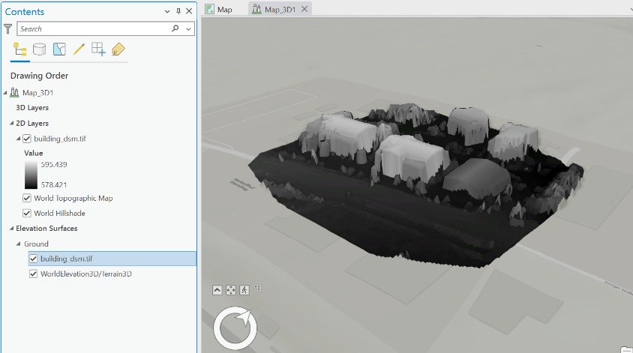

Screenshot G1

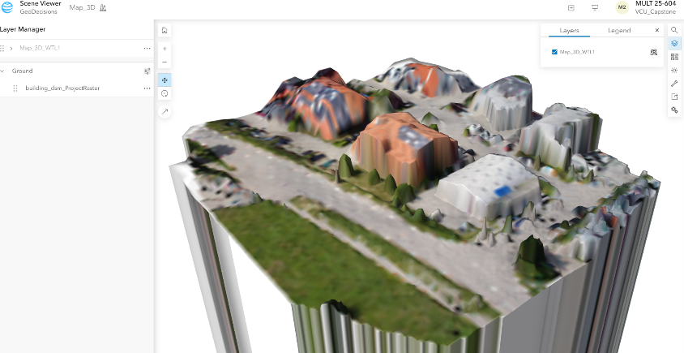

Screenshot G2

In practice, this problem was simplified by the use of SiteScan, which allows for direct importing of aerial photographs and cloud-based processing, instead of generating 3D geometry and interpolating color data onto the model afterwards. As a result, models were simple to produce without satellite-based elevation data or the need to have a high-end graphics card to process the data locally. Below in *Concept Execution* are examples of the datasets and models produced within SiteScan.

The other process explored was processing LiDAR data, and a LiDAR dataset was found online with a *.las* file extension. That was also imported into ArcGIS Pro in order to process and view the data. The following were produced, the first in ArcGIS showing the LiDAR data and its relation to the default hillshade and the second showing the data being displayed in ArcGIS Online. Once imported into an ArcGIS scene, the point cloud is automatically interpreted to provide a comprehensive mesh of the area, surface, or structure scanned.

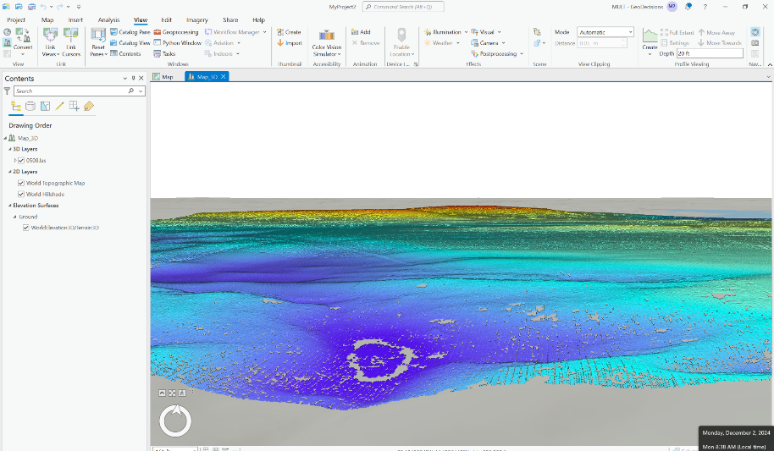

Screenshot G3

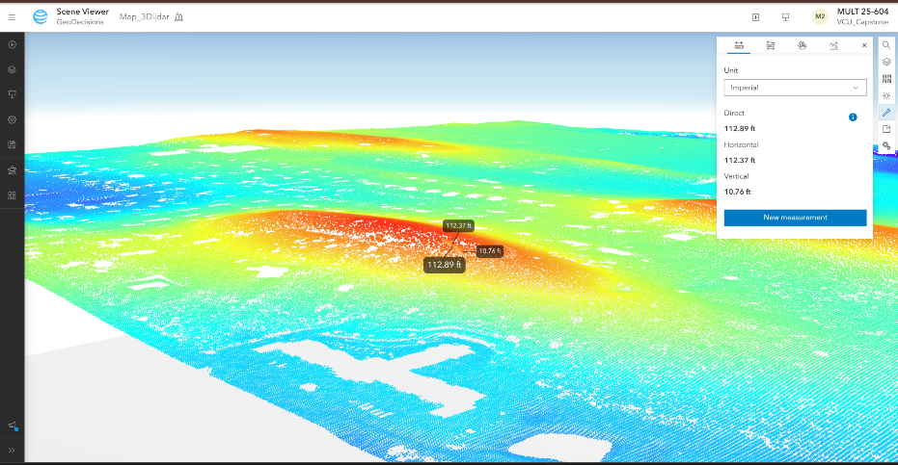

Screenshot G4

In screenshot G3, it is clear that the LiDAR data follows well the contours of the ground and is displaying well in the scene, which means that to that point, we have a good process defined. The data moves well to ArcGIS Online, except that the z-axis values again get distorted and the model ends up high in the air. This is again just a projection issue, and will be something that will be worked on as the project progresses. Screenshot G4 also shows the use of the measurement tool that is by default enabled in the scene viewer, and something that will be useful in custom scenes and maps as we work more closely on the ArcGIS Online side of the project. The LiDAR data that is used here covers a much larger area than what will be used during the project, and has less complex shape, which will be other considerations as we begin doing our own scans with the LiDAR.

#### Concept Execution

Once the team was able to gain access to SiteScan and the parts for the LiDAR and drone were ordered, the project shifted from using data that was already pre-produced to creating data collected from local sites to use for producing models that were taken fully from the data collection stage to the final viewer. For details on the steps taken to go from raw data to the models, see Appendix 3, which details step by step how each process was done and what equipment and software were used for each implementation.

The first full photogrammetry model that was produced was created by flying the Mavic Air 2 around Spring Run Presbyterian Church in Chesterfield County, Virginia. Images were collected both from overhead and at oblique angles to create a fleshed out 3-dimensional model. The following are screenshots of the point cloud (G5) and the final mesh model superimposed over a base map layer (G6).

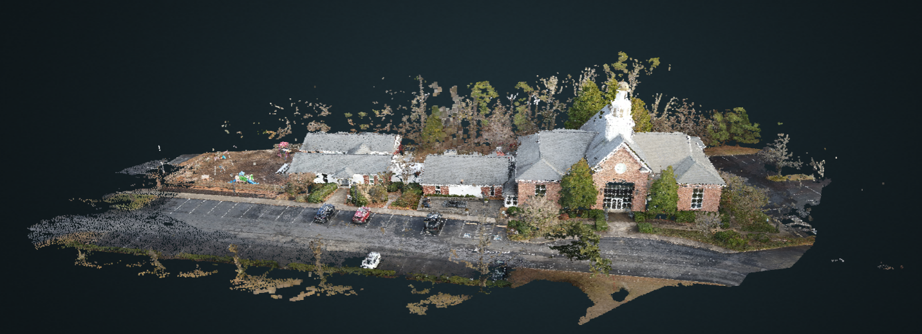

Screenshot G5

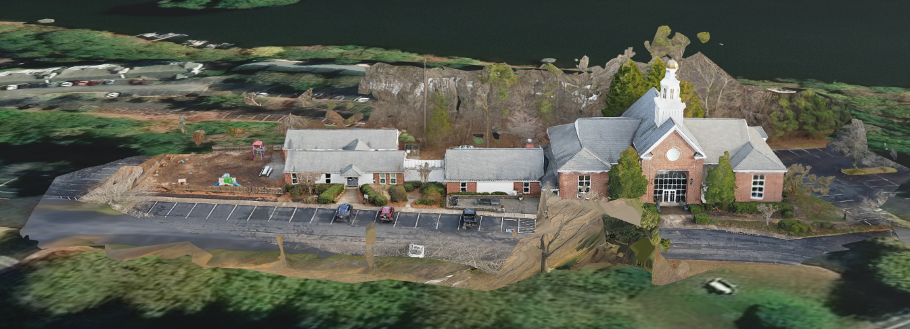

Screenshot G6

Two other photogrammetry runs were done after the church model was successfully completed, both to support analysis or proof of concept that GeoDecisions wanted done for two structures specifically. These were the Z-Dam (G7) and Williams Island (G8) dams, both located close to Pony Pasture park in Richmond, Virginia.

### 

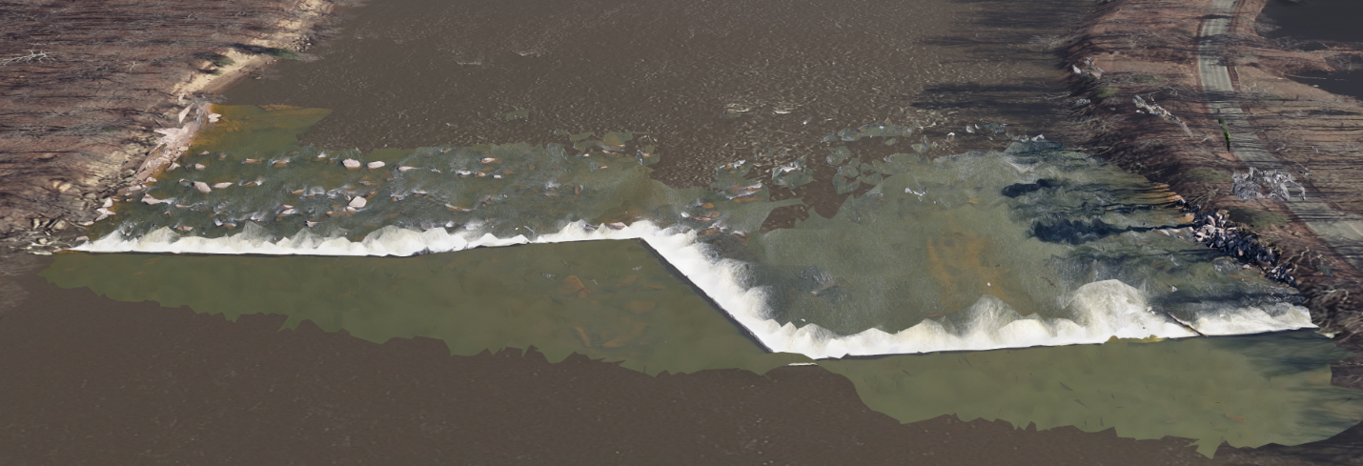

Screenshot G7

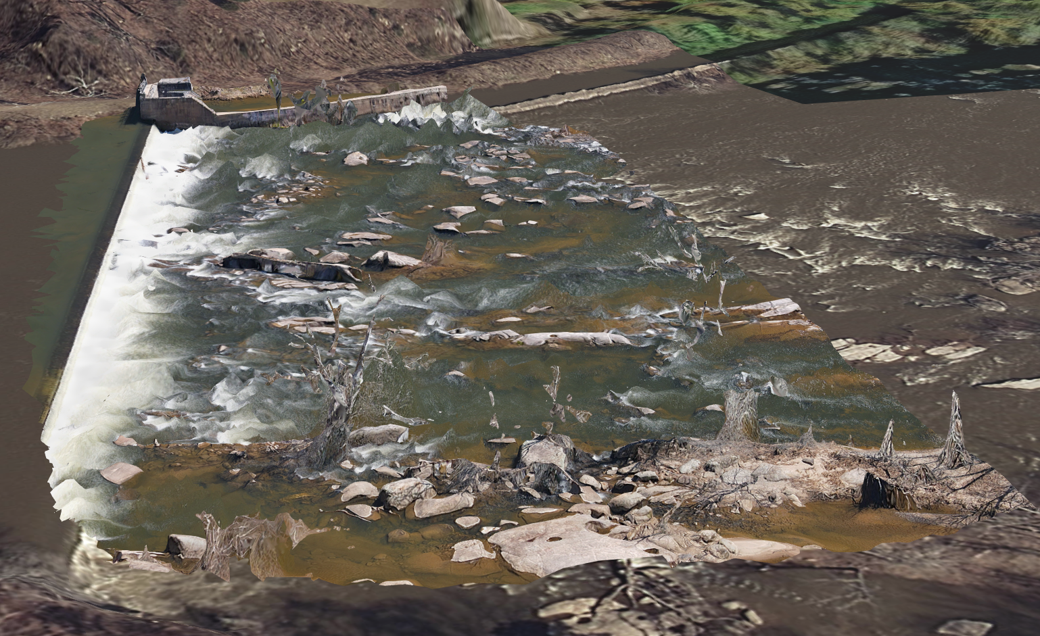

Screenshot G8

The models of each of the dams ran into some complications regarding their ability to stitch together water accurately. These concerns are mitigated in their point cloud representations decently, but the mosaic models do not accurately represent the water surface, although consistent features do remain accurate, including those submerged under the water.

A successful LiDAR model was also produced and exported from the drone’s Raspberry Pi into ArcGIS Pro. An LAS file was created from the PCD file that was generated by the LiDAR module’s default software development kit. A picture of the LiDAR model displayed in a 3D scene in ArcGIS Pro is included in Screenshot G9.

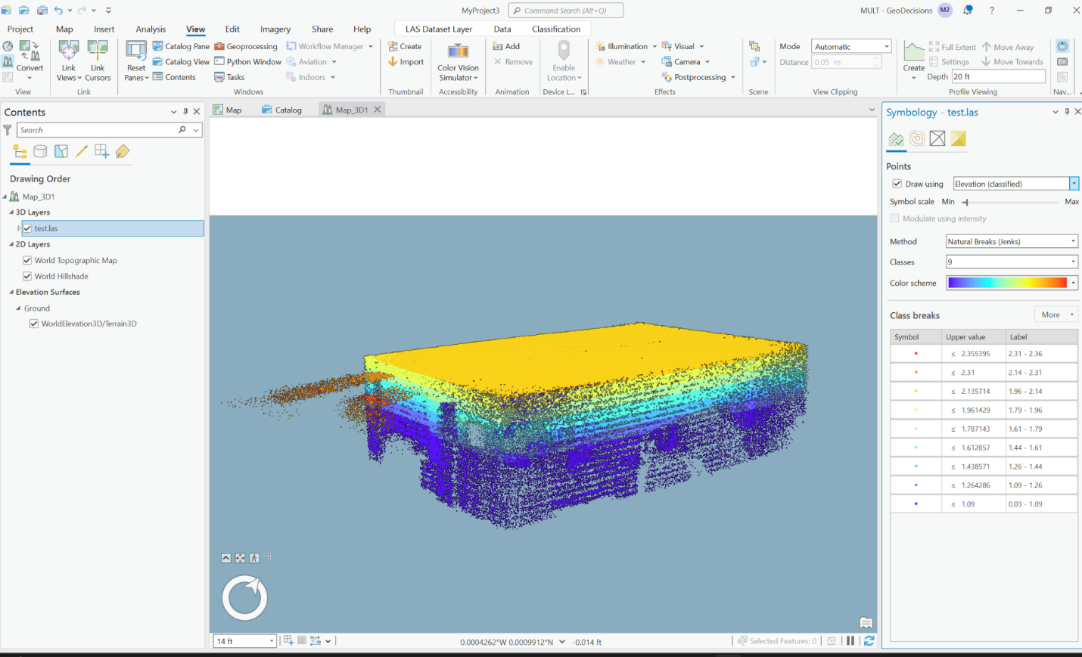

Screenshot G9

### Section H. Societal Impacts of Design

#### H.1 Public Health, Safety, and Welfare

The drone component of the project is perhaps the most applicable to health, safety, and welfare concerns. Because drones do come with a small level of risk, there is always the chance that something could go wrong during flight and end up injuring someone. While legal precautions aim to eliminate some of these concerns, the operator must remain wary of people in the nearby area and must not put the drone at risk of hurting someone. Beyond physical injuries, drones have some privacy concerns that might impact public well-being, as well as sometimes being loud and disruptive when flown around people. Any flights must do their best to reduce those impacts.

#### H.2 Societal Impacts

Because Geodecisions works with many clients who have projects that are providing benefits to the public through infrastructure and production, the project has a societal impact in providing the purveyors of these publicly used projects the best geospatial information that photogrammetry and LiDAR are able to provide within the ESRI scope. They will have the ability to use the information gained through replications of the process defined by this project to make informed decisions that will make their projects more safe and more beneficial to the public.

#### H.3 Political/Regulatory Impacts

There are few policy impacts that may result from this project, save any that may come from the benefit that this process may have in advising regulatory agencies or legislators through GeoDecisions’ relationship with its clients. All applicable drone and photography laws will be strictly adhered to by anyone involved in the project.

#### H.4. Economic Impacts

The nature of producing this detailed process was to provide a method for GeoDecisions to most effectively communicate its geospatial data to its clients in a way that allows them to visualize and make informed decisions about projects that they are working on with the firm. In this way, the results of this project will be able to be implemented into the workflow of members of the GeoDecisions staff to work with clients and help to make the best and most informed business decisions. It will also provide a relatively cost effective way to produce imagery through the use of smaller hardware such as drones that can be operated by someone within the company rather than to have to contract out with an aerial photography firm that may charge a large amount of money and that would need to be paid for each project. This allows employees within Geodecisions to produce their own aerial maps and three dimensional models whenever it is necessary, which is a financial benefit to the company.

#### H.5 Environmental Impacts

The design process by its nature has little physical development, but there are still impacts that the overall project may contribute to the environment. Because many of Geodecisions’ clients are in infrastructure, and these projects are outdoors and must be implemented within the physical natural environment, the insights that will be provided through use of the completed process will be able to help the clients make informed decisions that will be in the best interest of natural preservation and that will allow projects to be seamlessly integrated with their surrounding nature. One thing that a user of the process must be conscientious about is the flying of the drones and the potential impacts that can have on wildlife in the areas around where the drone is being operated.

#### H.6 Global Impacts

Photogrammetry and LiDAR data are already collected and processed at a global scale in order to create depictions of the earth and to provide geospatial information to users both professionally and personally. As this project expands on some capabilities that are already available and implemented, the resulting documentation from the project will provide detailed explanations and instructions on how to use the specific toolset defined by the sponsor to create such representations of data. Furthermore, Geodecisions serves clients at the federal, state, and local government level and in the power and energy, transportation, and water utilities sectors. With clients in such a broad array of industries and at different levels of government, this project will provide the company an effective and optimized method to serve these clients using the methodologies that have been developed and condensed into the Technical Plan of Operation. This will allow the company to provide a consistent product and representation of their projects to their various stakeholders and a uniform method of collecting and retrieving data for different clients.

#### H.7. Ethical Considerations

Photographic content naturally elicits thoughts about personal information being digitally stored and recorded, and the ability of drones to maneuver around buildings and populated areas are also something to consider. Photography of individuals when collecting data for a run through the pipeline should be kept to a minimum and avoided unless they explicitly consent to being in the photographs. This applies to panoramic photographs as well. Drone flying for the purposes of collected photographs and imagery for the pipeline should be done with proper discretion and regard for the people and buildings in the surrounding area. Drone flying should only be conducted for the explicit purposes of creating the model and should not be used recreationally when conducting a site survey. Proper licensing and certification should be used when flying drones. Any people in the area of the flight should be informed of the reason for the drone and the area covered if it poses a significant disturbance of privacy or safety. Data maintained in the GeoDecisions ArcGIS accounts and for site surveys should only be shared with the relevant parties so that no trade or industry confidential information is able to be obtained by a third party. Caution should therefore be used when displaying created models or other data to someone not involved in the project.

### Section I. Cost Analysis

This section provides a detailed cost breakdown and justification for all components used in the development of the prototype. Our goal was to create a functional, affordable drone-based LiDAR and photogrammetry system without exceeding a modest project budget. Purchases were made across several vendors, including Amazon and DigiKey, while certain components were manufactured in-house at HackRVA to reduce cost.

It is worth noting that the cost of software licensing for the photogrammetry drone is not included in this breakdown, as it was provided free of charge by GeoDecisions for use by the project team. The cost of a 12-month SiteScan license is likely double that of the hardware for the LiDAR drone, and should be considered as the most significant expense of the project, despite the team not directly paying for it. Estimated cost was given at around $5,000 for a 12-month license, but alternatives exist which achieve much of the same functionality at a lower price point. While SiteScan is not required in any way to produce the LiDAR drone or datasets, it is an integral part of the project as it was defined (i.e. staying within the ESRI suite), and bears mentioning as an underlying cost of the project as a whole.

Thanks to additional financial support from Dr. Motai’s lab, we were able to exceed the original $1,000 budget for this project. This allowed us to acquire the Radiolink M435 drone and other key components necessary for a functional LiDAR-based system without compromising on quality or capabilities. This supplementary funding was crucial in enabling us to develop a more robust and scalable prototype.

Cost Breakdown of the Project

|  |  |  |  |
| --- | --- | --- | --- |
| **Item** | **Unit Cost** | **Total Cost** | **Notes** |
| RadioLink M435 Heavy Lift Drone | $1299.00 | $1299.00 | Heavy-lift platform with payload mounting plate |
| RadioLink PRM-03 Module | $18.99 | $18.99 | Live battery/flight data telemetry |
| UniTree L1 RM LiDAR | $309 | $309.00 | Lightweight 360° LiDAR with onboard IMU |
| Raspberry Pi 4 Model B (8GB) | $75.00 | $75.00 | Onboard computer, headless capable |
| 256GB microSD Card | $19.99 | $19.99 | Storage for OS and LiDAR data |
| RPi Heatsink + Fan Kit | $8.99 | $8.99 | Cooling system for Raspberry Pi |
| HDMI Adapter + Dummy Plug | $6.49 | $6.49 | Allows headless Pi operation and monitor debugging |
| Rii K06 Wireless Keyboard | $22.99 | $22.99 | Remote access to Pi when needed |
| USB 5V to 12V Boost | $11.99 | $11.99 | Steps 5V power supply up to 12V for LiDAR |
| 10,000mAh Power Bank (2ea.) | $29.99 | $59.98 | One for Pi, one for LiDAR power, USB and USB-C outputs |
| 3.5mm x 1.35mm Barrel Plug | $6.95 | $6.95 | For LiDAR power connection |
| HDPE Plate (12” x 12” x 3/16") | $15.99 | $15.99 | Payload base for drone |
| M2.5 + M3 Screws, Standoffs (Kit) | $9.99 | $9.99 | For mounting Pi and LiDAR securely |
| 3M Industrial Strength Velcro | $6.99 | $6.99 | For securing non-threaded components |
| 8” Zip Ties (50 lb tensile) | $4.99 | $4.99 | Fail-safe secondary attachment |
| USB to USB-C | $7.99 | $7.99 | Data/power cables for Raspberry Pi and LiDAR support board |
| Balance Plug Extension | $7.99 | $7.99 | Used for optional telemetry integration |
| 3D Printed Housing | $0.00 | $0.00 | Custom printed to fit payload configuration |
| **TOTAL** |  | $1894.31 |  |

#### Procurement and Manufacturing Summary

* **Amazon** was used for the majority of components due to fast delivery times and competitive pricing.
* **HackRVA**, a local makerspace, allowed us to fabricate a custom Raspberry Pi housing at no cost using 3D printing tools and materials available on site. This helped reduce both cost and weight for drone mounting.

#### Cost Efficiency Considerations

* The **Unitree LiDAR** was selected over more expensive alternatives like Velodyne or Ouster units due to its balance of performance and price.
* The **Radiolink M435** provided a heavy-lift capacity at a significantly lower cost than professional-grade drones, without sacrificing stability.
* By using the **Mavic Air**, provided by the sponsor, for photogrammetry, we avoided the need for additional drone purchases.

#### Commercialization Estimate (Preliminary)

If this design were to be scaled into a commercial product, the following estimates would apply:

* **Fixed Capital**: $1,000–$2,000 (for 3D printers, test rigs, assembly tools)
* **Raw Materials**: $1,000–$1,400 per unit (excluding bulk discounts)
* **Manufacturing & Assembly**: ~$200 per unit (labor, testing, packaging)
* **Projected Production Cost**: $1,500–$1,700 per unit

Further reductions could be achieved through:

* Volume discounts on components
* Custom PCB design to eliminate off-the-shelf boards
* Lightweight, injection-molded casing to replace 3D printing

### 

### 

### 

### Appendix 1: Project Timeline

Here is a Gantt chart that outlines a rough timeline for the project. This Gantt chart can be subject to change depending on the design and implementation of the project. It specifies over which period of time each phase of the project should be completed and ensures that the project is progressing as it should over its duration. This is meant to keep the team on track and to give a rough estimate of when certain tasks should be completed to be on track with submitting the project and deliverables in an appropriate time frame.

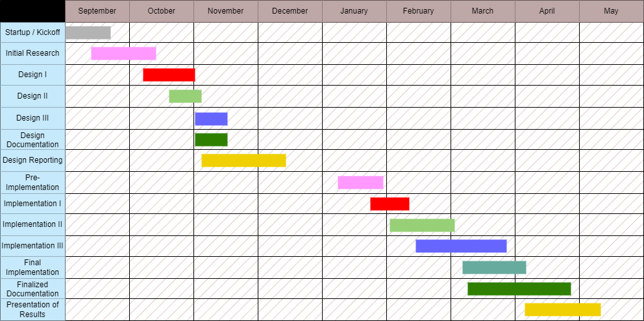

### Appendix 2: Team Contract (i.e. Team Organization)



MULT 25-604 – Aerial Precision: 3D Reality Capture and GIS Integration with Drone Technology

**Team Contract**

Prepared for

Matt Merrill

GeoDecisions

By

Adil Adil

Grady Beck

Colin Drake

Nathan Germain

September 4, 2024

Contents

Step 1: Get to Know One Another 2

Step 2: Team Culture. Clarify the Group’s Purpose and Culture Goals. 3

Step 3: Time Commitments, Meeting Structure, and Communication 4

Step 4: Determine Individual Roles and Responsibilities 5

[Step 5: Agree to the above team contract 6](https://docs.google.com/document/d/1iB8jfZwFbzOrGAgHc2QS5s-RtAHBWuWo/edit#heading=h.1t3h5sf)

# Step 1: Get to Know One Another. Gather Basic Information.

|  |  |  |  |
| --- | --- | --- | --- |
| ***Team Member Name*** | ***Strengths each member bring to the group*** | ***Other Info*** | ***Contact Info*** |
| Adil Adil | Circuit Design, Programming, Problem Solving, Time Management, Work Ethics, Leadership, Task Allocation, Drone Experience | VCU Makerspace Certified, FSAE Experience | adila2@vcu.edu |
| Grady Beck | Programming, Drone Experience, GIS Experience (ArcGIS), Time and Resource Management, Work Ethic, Communication | Computer Science Student | beckgm@vcu.edu |
| Colin Drake | Communication, project management, results-driven, prototyping, programming | VCU Makerspace Certified | cdrake3@vcu.edu |
| Nathan Germain | Problem-solving  Some experience in FPGAs and embedded design, Logistics | VCU Makerspace Certified | germainnt@vcu.edu |

|  |  |  |
| --- | --- | --- |
| ***Other Stakeholders*** | ***Notes*** | ***Contact Info*** |
| *Faculty Advisors*  (Yuichi Motai, Tamer Nadeem) | Dr. Motai is the ECE advisor.  Dr. Nadeem is the CS advisor. | ymotai@vcu.edu  tnadeem@vcu.edu |
| *GeoDecisions*  (Matt Merrill) | Senior Technical Solutions Director | mmerrill@geodecisions.com |

# Step 2: Team Culture. Clarify the Group’s Purpose and Culture Goals.

|  |  |  |
| --- | --- | --- |
| ***Culture Goals*** | ***Actions*** | ***Warning Signs*** |
| Openness about deadlines and objectives | - Be transparent about progress, especially if deadlines are close  - Be willing to schedule time for critical tasks, even when inconvenient | - Team members do not respond to requests for progress updates  - Vague scheduling conflicts without reason/justification |
| Responsive communication and professional decorum | - Requests for input and scheduling are replied to in a timely manner  - Team members assume positive intent, and constructively address interpersonal issues | - Team member provides deliverables with little time to integrate and bug check  - Not replying to group messages within a reasonable time |
| Collaborative engagement | - Divide and delegate tasks fairly, let each other work to our strengths  - Help one another where applicable, and make an effort to understand the work of others | - Hogging drone flying time  - Regularly delegating work to others without producing personal results |
| Informal gathering and teambuilding | - Find time to meet where project work isn’t the priority  - Engage in common interests, study other classes, gripe about work, etc. | - Repeatedly finding excuses to avoid informal gatherings |
| Standards and uniformity | - Documentation and communication are to be formatted in a standard fashion to promote professionalism | - Comic Sans  - Arial |

# 

# Step 3: Time Commitments, Meeting Structure, and Communication

|  |  |  |
| --- | --- | --- |
| ***Meeting Participants*** | ***Frequency***  ***Dates and Times / Locations*** | ***Meeting Goals***  ***Responsible Party*** |
| Students Only | As Needed, On Discord Voice Channel | Update group on day-to-day challenges and accomplishments |
| Students Only | Every Wednesday Evening, on Discord and every Monday in person after faculty update meeting (below) | Actively work on the project and update any documentation we have or need (everyone participates) |
| Students + Faculty advisors | Will meet on Monday at 3:30pm in ERB 2308 | Update the faculty advisors and get more information about certain aspects of the project. |
| Project Sponsor | Once a Month, Either over Zoom or in person | Determining Project expectations and goals, requirements, and feedback. Each team member is responsible for being present for meeting |

# Step 4: Determine Individual Roles and Responsibilities

|  |  |  |
| --- | --- | --- |
| ***Team Member*** | ***Role(s)*** | ***Responsibilities*** |
| Adil Adil | Systems/Mfg Engineer | * Leads design and fabrication process. * Test any Hardware manufactured. |
| Grady Beck | Financial Manager | * Budgets project funds and handles financial records. * Encourages responsible use of funds and materials. |
| Colin Drake | Project Manager | * Develops schedule and project agenda. * Maintains and promotes a positive environment within the group. * Provides point of contact to outside parties as needed. |
| Nathan Germain | Logistics Manager | * Coordinates use of reserved space, and storage space. * Collaborate with the team and faculty to allocate resources and plan events. |

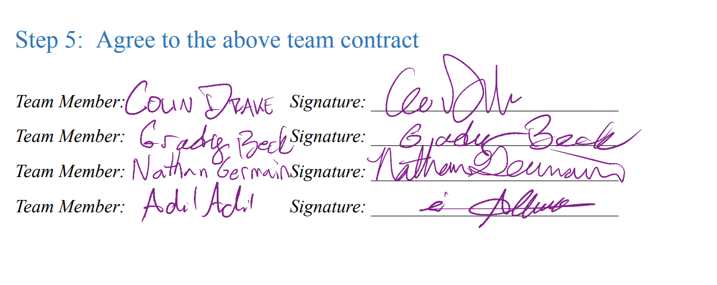

### References

[1] Esri. "GeoDecisions." Accessed September 29, 2024.<https://www.esri.com/partners/geodecisions-a2T70000000TNRDEA4>.

[2] FlyGuys. "5 Industry Use Cases for LiDAR." Accessed September 29, 2024. [https://flyguys.com/5-industry-use-cases-for-LiDAR/](https://flyguys.com/5-industry-use-cases-for-lidar/).

[3] PIX4D. "Five Industries That Use Photogrammetry." Accessed September 29, 2024.<https://www.pix4d.com/blog/five-industries-that-use-photogrammetry/>.

[4] University of Pennsylvania. "GIS Resources: Geographic Information Systems (GIS)." Penn Libraries. Accessed September 29, 2024.<https://guides.library.upenn.edu/c.php?g=475370&p=3254298>.

[5] GeoSolutions Group. "MapStore Technologies." Accessed September 29, 2024.<https://www.geosolutionsgroup.com/technologies/mapstore/>.

### Appendix 3: Technical Plan of Operations (TPO)

Technical VCU Capstone 2025  
Plan of Aerial Precision  
Operations Adil, Beck, Drake, Germain

Introduction

Section I – Photogrammetry

Hardware

Software Suite

Data Collection

Data Processing

Section II – LiDAR

Hardware

Parts List with Links

Software Installation and Setup

Assembly of the Sensor Payload

Drone and Transmitter Configuration

Payload Installation

Data Collection

Data Processing

Section III – Notes and References

# Introduction

The purpose of this document is to outline the process and functionality for creating three dimensional models by using photogrammetry or LiDAR data. This document was commissioned by GeoDecisions through Virginia Commonwealth University’s capstone program. The following methods were produced through the research and design of the assigned capstone team.

Section I outlines the 3D modeling process using the ESRI software suite, and specifically SiteScan, through photogrammetry, which stitches georeferenced photographs together in order to create models that can be manipulated. Section II outlines the 3D modeling process using LiDAR data collected from a LiDAR sensor, which uses lasers to transmit data and construct a point cloud based on the receipt of the transmissions after they have been reflected back to the sensor. Section III describes the improvements that could be made to further enhance the models produced or the ease of collecting data.

Screenshots are included to demonstrate how to follow the processes where applicable. This guide aims to display how to go from raw data collection to displaying the data in a viewer. The following sections will first outline the necessary equipment and capabilities and then will proceed step by step through the process until a finished model is completed. Results will vary slightly as custom data will be used each time this process is repeated, but by following the processes and guidelines set forth in this document a working model should be created in each instance.

# Section I – Photogrammetry

This section focuses on the hardware and software used to capture and process aerial drone photos into a photogrammetry product compatible with the ArcGIS suite and related modules. Since most of this process involves utilizing existing tools and relies on the user’s understanding of ArcGIS, screenshots will describe the bulk of instruction on how to produce photogrammetric meshes.

## Hardware

Hardware selection is limited only by the price point of the drone and camera system, but very clean results were achieved with a consumer-grade drone flown by line of sight around the areas of interest. In using a readily available (at time of writing) drone, the **DJI Mavic Air 2** with its built-in **48MP still camera**, it was ensured that similar results would be reproducible with a comparable system by future users. Since the processing software is platform-agnostic, any high quality drone photo sets should provide accurate models, assuming a good GPS lock.

## Software Suite

The software for photogrammetry outlined in this document is **ESRI’s SiteScan**, a photo-to-model cloud processing tool that takes georeferenced photos as inputs and outputs a three dimensional mesh. This simplifies 3D model generation by reducing the need for powerful local processing, and avoiding projection mapping photo data onto separately generated models. It should be noted that the cost of a SiteScan license is not included in the price breakdown due to it being provided by GeoDecisions free of charge for use by the project team. This cost is likely to be the largest expense, at around $5,000 for a 12 month license, but alternatives exist (e.g. Pix4D) that can accomplish much of the same functionality at a lower price point. The geometry produced by this software is exportable as files or directly to **ArcGIS Pro**, where it can be further refined with plugins and placed on a basemap to provide context to the scan site. From there, scenes can be viewed within **ArcGIS Online**, keeping the process within the ESRI suite wherever possible.

## Data Collection

*Drone flights should be performed in accordance with all federal, state, and local laws. If in doubt, consult with local authorities and/or a legal representative.*

Capturing good photogrammetry data relies on a few factors beyond just the drone and camera. Among these are the ability to receive accurate GPS data on the drone, wind and weather conducive to stable flight, and lighting conditions that produce limited shadows, which might interfere with the edge-finding algorithms. Below are a handful of useful tips to keep in mind when making data collection runs for photogrammetry:

* Proper photo overlap is essential for stitching. For the best results, aim for about 80% overlap between photos.
* Extend the photos taken a good bit beyond the edge of where the model should end. Even if something is included in the pictures, there might not be enough data to include it in the model. To prevent this, try having the photographs go well past the area where the edge of the model should be, and continue that overlap.
* Take both nadir and oblique images. Most of the photos should be done in passes that are straight overhead, but to add depth and additional height information to the model, take images that are angled towards the structures.
* At least three rows of passes should be taken to provide the proper overlap. Aim to take the pictures in a grid pattern with the 80% overlap, moving the drone slightly in the direction of the row, and then when the row is finished, move the drone up or down on that grid and then proceed in the other direction, taking pictures as you go across.
* SiteScan offers a flight tool to plan a flight and fly the drone automatically. This functionality is only offered through the iPad version of their app, so an iPad would be required if desiring to have the flight perform autonomously.

While not implemented here due to a lack of accurate GPS equipment, information about Ground Control Point formats can be found at this link:

<https://support.esri.com/en-us/knowledge-base/how-to-set-ground-control-points-for-use-in-site-scan-m-000023042>

## Data Processing

Processing the data involves uploading the photos into the ArcGIS SiteScan module, which processes the photoset into a variety of photogrammetric products that are easily placed on a basemap. This section assumes that photos have already been taken and all data needed is already collected. If this is not done, go back to the data collection section.

SiteScan credentials are required. To begin, log into SiteScan, which will bring you to the main screen.

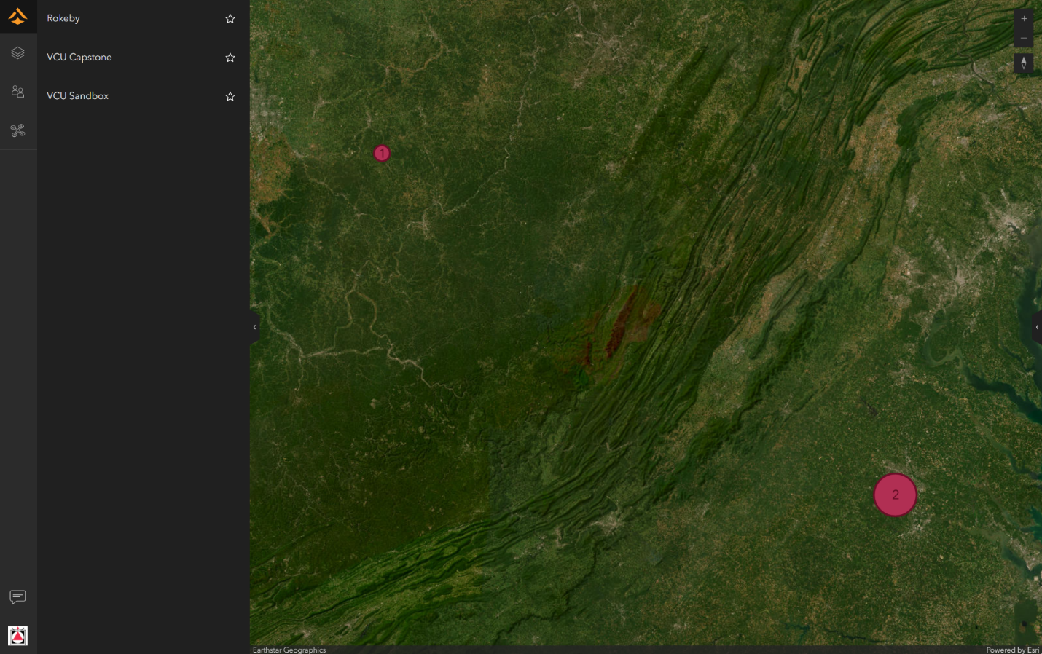

This page lists all of the projects. The icons on the left allow navigation to, in order, the project list, a list of people in the organization, and drone fleet management.

**Getting Started: Creating or Selecting a Project**

A project serves as a container that holds different missions and scans pertaining to a particular location or work product.

In order to create a new model, select a project to work in or create a new one from the projects page, shown below. If you create a new one, you will need to select a location, coordinate system, and datum according to your preferences, as well as who will have access to it.

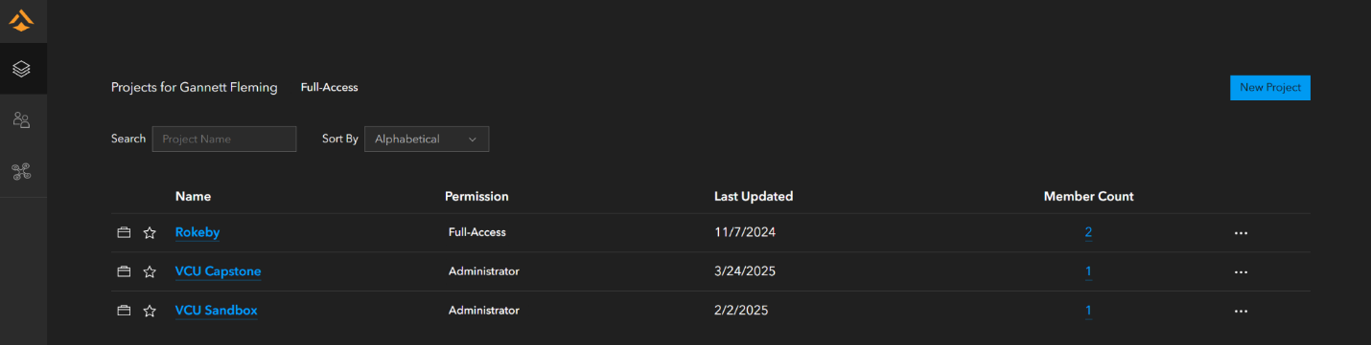

# 

**Select a Mission**

A mission in SiteScan is the collection of a single set of images to create a model. At this stage, if a flight plan was used, a mission will have already been created and that is the one that should be selected. If the flight was done manually, create a new mission.

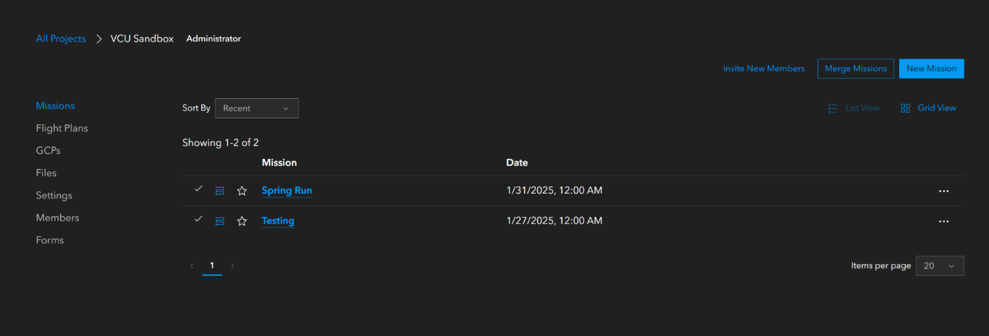

**Process the Photos**

Give the mission a name and date and upload the photos that were collected when prompted. Photos can also be uploaded using the plus button once the mission has already been created, found in the toolbar along the bottom:

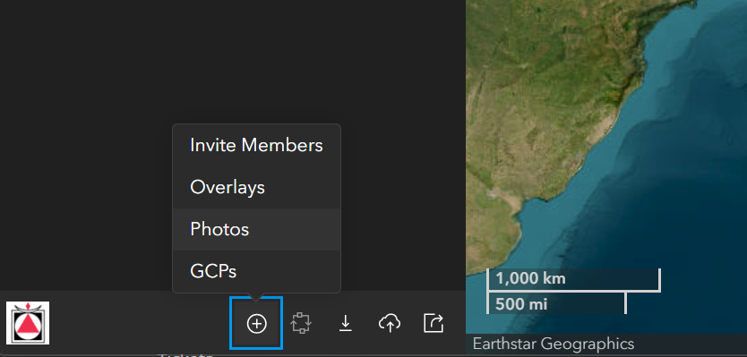

Once photos have been uploaded, they will need to be processed. The processing button is located to the right of the plus button above. The processing screen will require a few inputs before it begins.

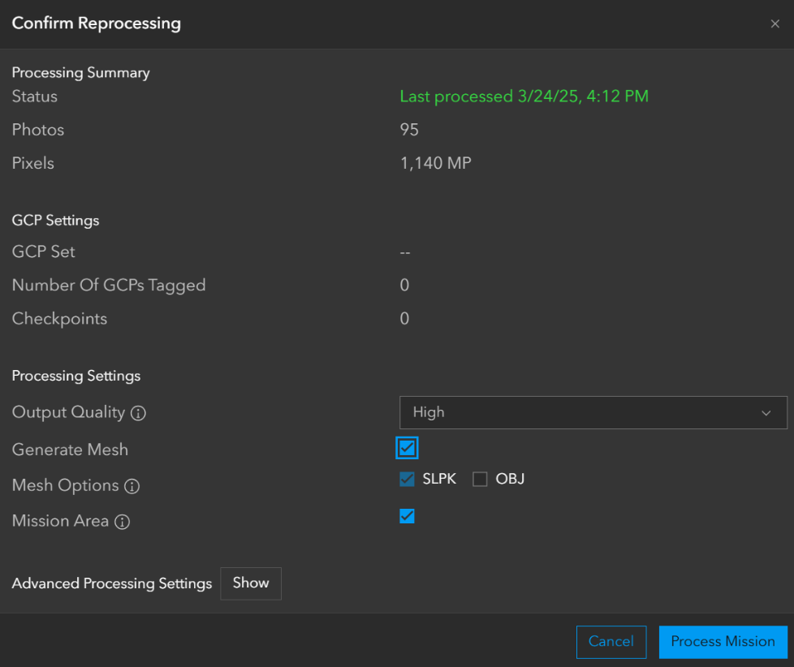

Be sure to click “Generate Mesh” and select which type of file output you would like to create under the mesh options. An SLPK will be sufficient for ArcGIS purposes, but for the model to be used in an external software, an OBJ file might be useful as well.

During some instances of processing the mission, if there is a mismatch between the coordinate system of the project and the photos, the processing screen will prompt the user to select an appropriate projection in order for the model to process correctly. In most instances, the SiteScan algorithm is able to auto-detect what that should be.

Processing time should take typically between an hour and two hours, and will fail if the projection system does not match up.

**Viewing the Output**

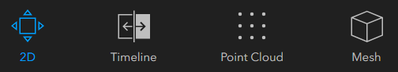

The bar in the top left displays which options may be used to view the data.

The 2D option shows an aerial view of the stitched together photographs.

# 

Clicking the timeline option allows for comparison of different models over time, and uses all the missions in the project to create an overlay.

The point cloud option shows a point cloud that has been generated by ESRI’s modeling system based on the stitching that was created using the photogrammetry. This view does not fill in the gaps and generally provides insight into the parts of the model which it felt was most accurate. For example, with the pictures taken over water, there is a lot less variability in the surface in the point cloud than in the stitched mesh.

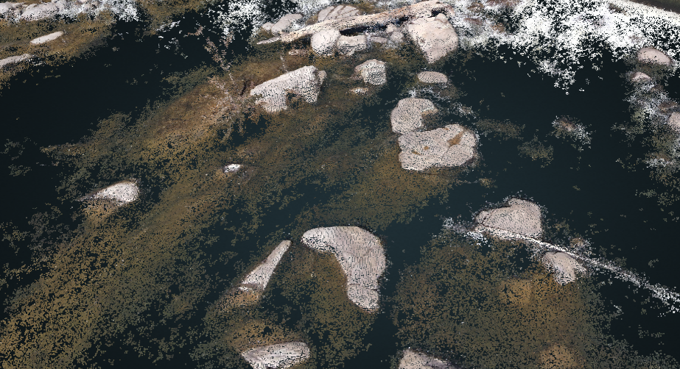

The last option, mesh, shows the fully created 3D model that has been produced with the images. It also allows it to be overlaid upon a map. Adjusting the offset for this model to align with the ground is a critical step to ensure the proper placement on the z-axis. This will also need to be done in ArcGIS if exported there.

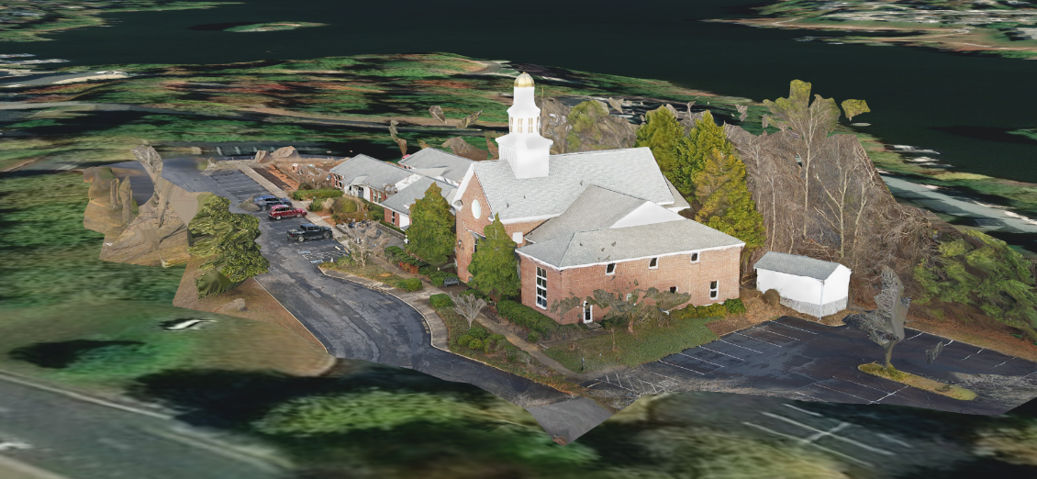



The project may be exported from SiteScan either by downloading the desired file format with the download button in the bottom bar (left of highlighted), or uploaded to ArcGIS Online using the button highlighted above. With the button on the right, a shareable link can be created that allows for a link to be sent that contains the current view so that someone external may view the results of the model.

Once exported into ArcGIS Online, create a new scene and select the desired layers to view in the Scene Viewer by using the add button in the top left.

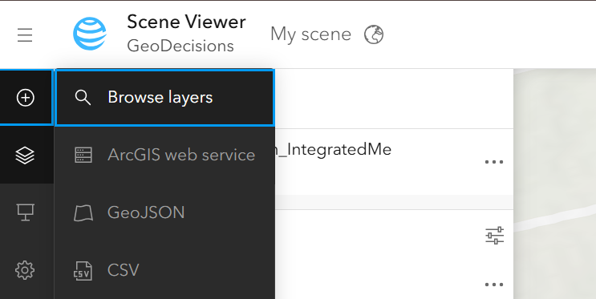

Add the desired layer. For this example, we will use the Integrated Mesh produced by our SiteScan. Other models, including the point cloud, are available as well.

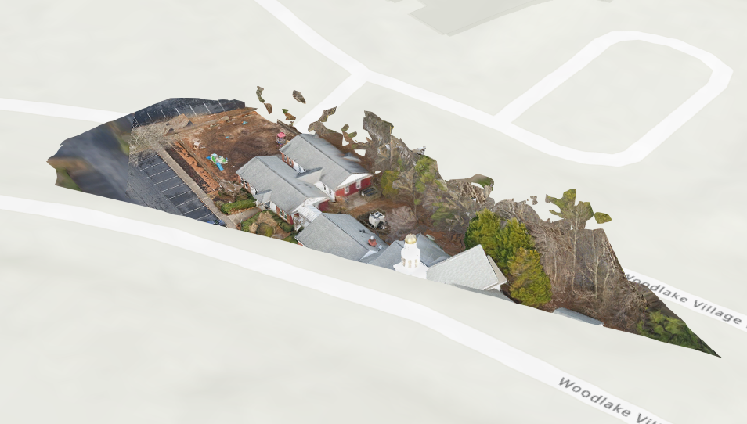

Once added, if the model sits above or below the surface as in the model above, go into layer properties as shown below.

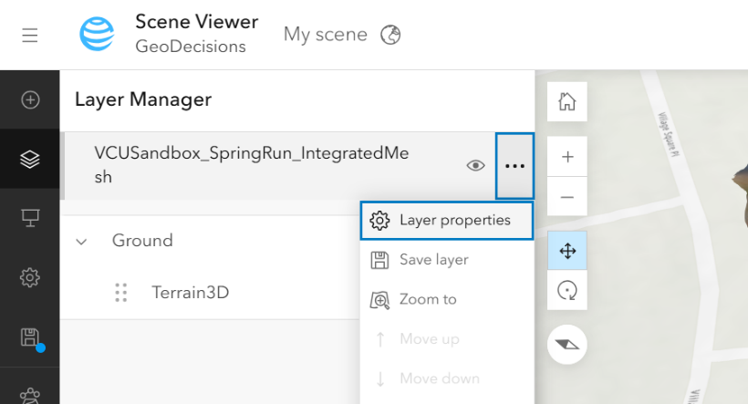

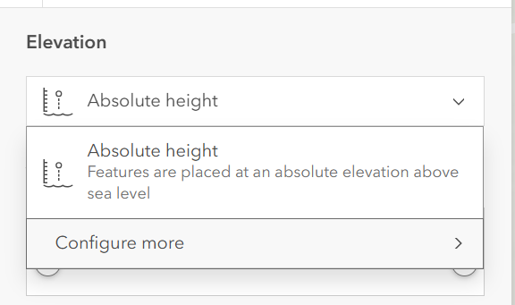

Choose to configure more under “Absolute Height,” and adjust the offset to be flush with the ground level. This will produce a working model in Scene Viewer.

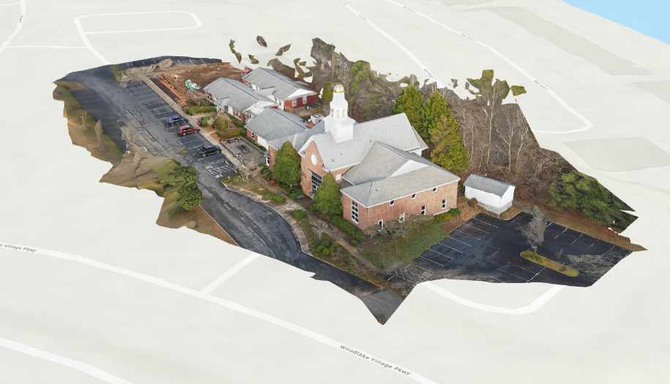

# Section II – LiDAR

## Hardware

Outlined below are the components and materials used to produce a LiDAR sensor payload that is easily mounted to a drone for aerial data collection. The system was developed to make use of as many off-the-shelf components as possible in order to reduce cost for the proof of concept design. In pursuit of this, a heavy lifting drone that allowed for a sizable payload to be mounted underneath was desired. Selection of the LiDAR sensor was based primarily on weight, as well as footprint, since those criteria determine the flight worthiness of the system as a whole. The choice of microcontroller was driven by data throughput of the LiDAR sensor, ability to operate remotely from user input, and power consumption requirements. Supporting these primary components are a collection of power supplies, voltage regulators, and mounting hardware to secure the payload to the drone.

* **RadioLink M435** 
  + Heavy lift drone with 6.6 lbs (3kg) capacity, includes payload plate
  + Available with FPV capabilities built-in and ready to fly
  + Customizable, modular flight controller for added functionality
* **UniTree L1 RM LiDAR**
  + 360° x 90° scan area allows for hemispheric LiDAR capture
  + 8oz (235g) overall weight, 3” (75mm) square footprint
  + High rate capture (~20k points/sec) and ~100ft (30m) range
  + Onboard IMU allows for LiDAR Inertial Odometry (LIO)
  + Includes ‘support board’ for serial-USB conversion and power supply
* **Raspberry Pi 4 Model B**
  + Open source development tools, support for remote (headless) use
  + Size/weight and power consumption (5V 3A)
  + System familiarity (Linux based, not GPU-driven e.g. Jetson)
* **5V 3.5A 10,000mAh Power Supplies**
  + RPi can be run directly from a power supply with no conversion
  + Simple boost converter (5V 3A > 12V 1A) can be used for LiDAR
  + Size/weight comprise bulk of payload, may limit installation options
* **Mounting Hardware**
  + 6” square 3/16” thick HDPE plate for payload base
  + 3D printed housing for RPi and LiDAR power supply
  + M2.5, M3 screws and standoffs for mounting RPi, LiDAR resp.
  + 3M brand “Industrial Strength” Velcro, for items without thru-holes
  + 8” 50 lbs tensile strength zip ties for backup attachment (fail-proofing)
* **Other Electronics**
  + RadioLink PRM-03 telemetry module for live battery/flight info
  + Wireless keyboard/mouse for remote access to start new scan/reboot
  + HDMI dummy plug provides easy headless operation

### Parts List with Links

[RadioLink M435](https://radiolink.com.cn/m435_gps_FPV) (Mfg website)

[RadioLink PRM-03 telemetry module](https://www.amazon.com/dp/B08QMW1KRY) (Amazon)

[6S LiPo balance plug extension](https://www.amazon.com/dp/B0DHVKYVRZ) and [JST-SH 1.0mm 4-pin leads](https://www.amazon.com/dp/B08HQ1VSVL) (Amazon)

[Raspberry Pi 4 Model B](https://www.raspberrypi.com/products/raspberry-pi-4-model-b/) (Mfg website)

[256GB microSD card](https://www.amazon.com/dp/B0B7NV73PJ?th=1) (Amazon)

[RPi 4B Heatsink with Fan](https://www.amazon.com/dp/B07Z3Q417K?th=1) (Amazon)

[MicroHDMI to HDMI adapter](http://amazon.com/UGREEN-Adapter-Compatible-Raspberry-ZenBook/dp/B00B2HORKE?th=1) and [HDMI dummy plug](https://www.amazon.com/BKFK-HDMI-Dummy-Plug-3840x2160/dp/B0CJZFKQLR/?th=1) (Amazon)

[Rii K06 wireless keyboard and trackpad](https://www.amazon.com/dp/B0BML42L6X) (Amazon)

[UniTree L1 RM](https://shop.unitree.com/products/unitree-4d-lidar-l1?variant=44806258622697) (Mfg website)

[USB 5V to 12V Boost Converter](https://www.amazon.com/dp/B01ID90K4A?th=1) (Amazon)

[3.5mm x 1.35mm male barrel plug pigtail](https://www.amazon.com/dp/B08JK73SD9) or [90° plug](https://www.amazon.com/dp/B081TYG48P) (Amazon)

[12V 4.5A 10,000mAh Power Supply](https://www.amazon.com/dp/B0D94B7ZSH?th=1) [2 ea.] (Amazon)

[12” x 12” 3/16" HDPE plate](https://www.amazon.com/dp/B0D22T7TRQ?th=1) (Amazon)

[M2.5 screws](https://www.amazon.com/dp/B0CXQ4QTGT?th=1) and [standoffs](https://www.amazon.com/dp/B07KM5B3PT?), [M3 screws](https://www.amazon.com/dp/B0B51BFSWZ?) and [standoffs](https://www.amazon.com/dp/B0CBPGKDP4?) (Amazon)

[8” zip ties](https://www.amazon.com/dp/B0BCMYMP5W?), [3M 15 lbs Velcro](https://www.amazon.com/dp/B09V5FV7H8?), [Assorted heat shrink tubing](https://www.amazon.com/dp/B01MFA3OFA?) (Amazon)

[1ft USB to USB-C fast charging/data cable](https://www.amazon.com/dp/B08W28GQ4P/?th=1) [2 ea.] (Amazon)

## Software Installation and Setup

The software kit used for this project was the Unilidar L1 SDK and their implementation of the LIO algorithm. This uses a ROS implementation that runs within a Linux distribution.

For this project specifically, we used Ubuntu Server 20.04 and installed a GUI on that distribution. 20.04 was selected because one of the packages specified in Unilidar’s SDK documentation is only compatible with this version of Ubuntu, and at the time of implementation, Server is the only version of this distribution still available within Canonical’s downloads.

Once Ubuntu Server was installed, connected to the internet, and a GUI library installed, the two packages provided by Unilidar were built on the command line. Both packages were installed in the exact way specified in the README files within each directory, with the LIO SLAM library being the one that details exactly what needs to be running at which time in order for the program to run correctly.

<https://www.unitree.com/download/LiDAR>

The packages needed are the “Unilidar SDK Software Package” and the “Open Source SLAM Software Package”.

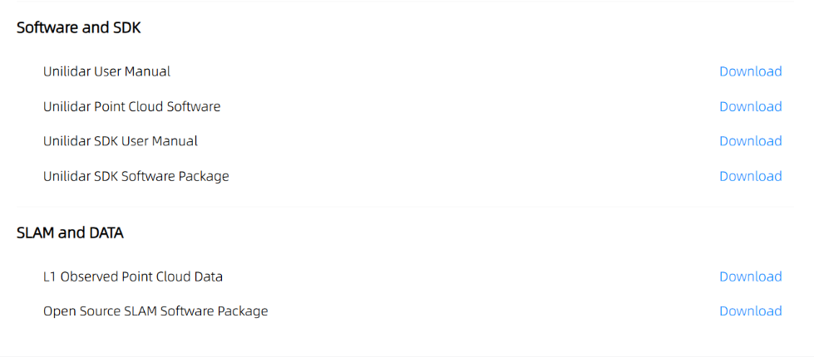

There were two main issues after having installed the packages when trying to build the project. First, the catkin_make command would only run after source devel/setup.bash had been run in each directory, so be sure to run that script before trying to use catkin_make. The other major hiccup happened when using catkin_make to build the project. The Raspberry Pi’s memory had a difficult time finishing the build process because of its computing resources. The way to fix this is to use a “-j4” option at the end of the make command that fails, and to create a swapfile within the Ubuntu OS that it can use for additional memory. The software should then build, but it may still take some time.

Once the software has been appropriately set up using the README instructions, the ROS system will need to be run, followed by the SLAM program in different terminal windows. The ROS system can run for the entire duration of the Pi being on, but running and stopping the LIO SLAM program starts and stops the data collection respectively. A viewer is provided to watch from the screen as the LiDAR collects data. Once the LIO program is done, it saves the scans.pcd file in a specified directory. Be sure to copy and rename this file to another location before running another LIO SLAM run, or it will be overwritten and the data lost.

In order to run the software while the drone was in the air, a bash script was developed for this project to start and stop the processes described above, as well as to copy the scans.pcd file to another directory and rename it, and then finally to convert the PCD file to an LAS file for easy input into ArcGIS. Two separate bash scripts were run in different terminals to prevent program interference between the LIO algorithm and the ROS program that powered it. The LIO bash script was started by the ROS bash script, and it also included the logic for the manipulation of the scans.pcd file at the end. Appropriate sleep times for the script were added to ensure proper program end and clean times, and sleep was also used to specify how long the LIO would run.

The bash scripts were set to run at startup every time the GUI started up. Some issues arose with a headless implementation, so the Pi needs to be configured where the display output is active, either through specifications in the hardware or an adapter for the HDMI that tricks it into thinking it is outputting to the HDMI. The renamed scans.pcd’s converted LAS file could then be extracted for use within ArcGIS once the algorithm had finished running and the specified time had elapsed.

## Assembly of the Sensor Payload

The two main components of the sensor payload that will determine overall layout are the LiDAR and the 3D printed enclosure for the RPi. Cabling and the boost converter are critical to keep clear of the rotors, but otherwise can be routed and secured where needed.

Developing the enclosure was done in Blender, using publicly downloadable files for the RPi 4B and L1 LiDAR to ensure accurate placement of mounting holes. Ventilation holes were added around the perimeter of the box to allow the heatsink fan to force warm air out into the airstream, but placed to allow voltage regulators to be Velcroed onto clean interior walls of the enclosure. Access was included for the RPi’s USB-C power port, USB ports (LiDAR data, keyboard and mouse), and microHDMI port (microHDMI adapter to HDMI dummy plug), with room to spare since dimensions vary across various plugs/manufacturers. Another hole is present to allow the power, data, and USB-C cables to reach the LiDAR support board, and a final hole near the top edge of the enclosure allows for a fool-proofing zip tie to be added once installed on the HDPE plate. The corners are reinforced and a tight fit (3mm) hole is provided for attaching the enclosure to the bottom of the HDPE plate. The model produced measures 110mm x 85mm x 50mm and is provided as an addendum.

1. **Layout components on HDPE plate** where they make sense, starting with the LiDAR to make sure it has the best field of view (at least forward and down unobstructed). The L1 LiDAR ignores all objects within 2” (50mm) of the center of the sensor, but should be kept as clear of the ground as possible. Next place the enclosure where it re-balances the plate back toward the center (assuming the LiDAR isn’t centered on the plate), generally behind the LiDAR. Be sure that all cables can be routed where needed, plug them in to verify flight setup will fit and not strain cables/ports. Cut the plate to size.
   1. **Build “blinders” to block the LiDAR**’s view of the drone. If portions of the drone are visible to the sensor and greater than 2” from the sensor, they will be recorded as part of the point cloud, which can complicate post-processing. Ideally, the blinders would be secured with screws and glue to keep them as solid as possible.
2. **Mark component mounting hole locations and drill** for close fit with M3 hardware (3.2mm). This can be undersized to 3mm since HDPE will self-thread with steel screws and a tight fit helps prevent vibration. Other holes can be drilled for zip ties: the enclosure zip tie, the four payload mounting zip ties at each corner of the plate, and any additional ones that are needed to secure the plate to the drone. Drill bits for plastic help prevent melting and tearing holes, and a sharp blade will clean up edges and holes very neatly with some practice. Included in the 3D files is a “lid” that can also act as a template for component mounting hole placement, since it was originally designed to support the LiDAR on top of the enclosure.
3. **Mark payload mounting hole locations and drill** to provide a way to bolt the HDPE plate to the drone’s carbon fiber load plate, as well as standoffs to prevent excessive flexing of the HDPE. The holes for mounting the payload need to be 1⅛” from the centerline running from front to back in order to line up with the most accessible slots on the load plate. This is important to the order of operations in payload installation. The standoff holes must lie directly below each of the 4 arms with motors on them, and in a position such that they prevent the battery packs from sliding forward or aft out of their straps. For the provided hardware list, this equates to about 6” apart, 1½” in from either edge along the diagonals (draw lines connecting opposite corners of the HDPE plate), assuming that the plate is mounted centered beneath the drone. **It is worth test fitting and judging the best location during payload installation.**
4. **Install RPi into the enclosure** using washers or standoffs to ensure height alignment with USB, power, and display ports. Use M2.5 screws through the heatsink, RPi, washers, and out the bottom of the enclosure. Secure them with nuts to provide good contact with the heatsink.
5. **Prep 12V boost converter** by cutting off the barrel connector included and soldering on the correct 3.5mm x 1.35mm barrel connector for the LiDAR support board. Similarly, shorten the USB side of the converter to prevent loose wires catching the rotors. Insulate/reinforce with heat shrink.
6. **Velcro LiDAR support board** inside enclosure onto interior wall opposite the power and HDMI ports. This way cables can be routed with maximum bend radius and extra length can be tucked inside once mounted to the plate.
7. **Route and plug in all cables to support board** (USB-C, 3.5mm x 1.35mm power, LiDAR 4-pin), verify position of 12V boost converter and velcro in place. This can be reinforced with an additional zip tie if ¼” holes are added to either side of the mounting location.

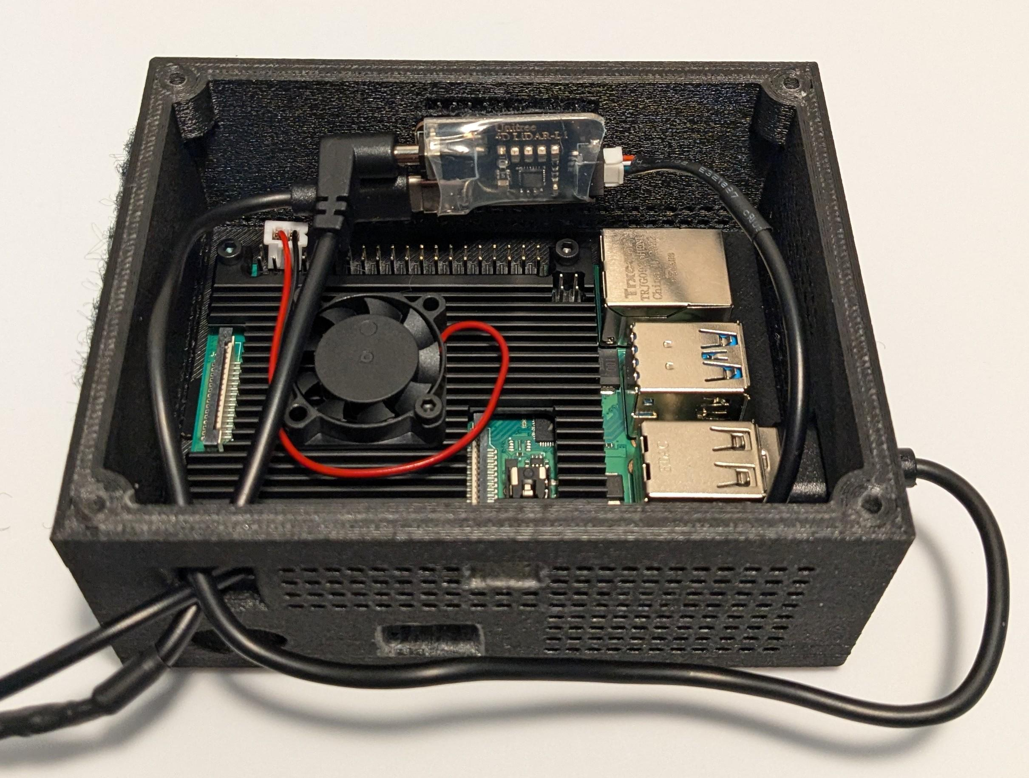

*Note hole placement, L-R from top left: LiDAR cable access, zip tie mounting point, oval-shaped power port access, microHDMI access. Rough edges indicate iterative development cycle.*

1. **Mount LiDAR to HDPE** with M3 screws and plastic washers, making sure to put relatively even torque on each screw and not overtightening (hand tight with the long end of an allen wrench).
2. **Mount enclosure to HDPE** with M3 screws and plastic washers, threading slowly in to make sure that the screw threads bite into the print lines of the enclosure. While this is a repeatable way to secure the enclosure, the addition of threaded inserts in the 3D print is likely to be superior. Use a zip tie through the appropriate hole in the enclosure and the hole provided in step 2 so that there is a backup should the print fail and the mounting screws come out. This zip tie can also be used to secure loose cables.

The sensor payload is now complete, and can be powered on and used as a standalone unit for testing, or for interior/small scale scans.

## 

## Drone and Transmitter Configuration

Successful flight can be accomplished out of the box with the M435 drone, but it is recommended to take some additional steps to ensure a smooth flight experience and support data collection operations. RadioLink provides a variety of drivers and a flight controller config tool (Mission Planner) based on the specific hardware being used, which provides a very detailed interface for modifying the drone’s settings. Similarly, the transmitter will need to be set up to match the settings selected on the flight controller with Mission Planner.

1. **Reset transmitter to clear current settings** and prevent overlapping or overwriting controls when making the changes below.
2. **Assign Channel 9 to Variable Slider D**, which puts the FPV camera tilt access at the right index finger slider (on the bottom of the transmitter).
3. **Set timers for 10 and 15 minutes, assigning them to Switch G** (3 pos.) so that one direction starts both timers, and the other direction resets them, with the center position unassigned to let the timers run. This will be the collection timer and the total flight timer, respectively.
4. **In SYSTEM settings, ensure that the data receive mode is set to SBUS** and that the flight controller’s output mode matches. The transmitter emits a colored light based on the transmit mode to help make this clear.
5. **With no battery connected, plug the flight controller into a PC** with a USB-C cable, and open Mission Planner. Connect to the proper COM port after the drivers install (you may need to manually install them from the RadioLink website). At this point, **run through the initial configuration tool**, which calibrates the drone’s gyros/accelerometers and sets the output range of the transmitter.
6. **In Mission Planner, set the flight attitudes** (there are 6 of them for the CrossRace flight controller) in a way that makes sense for the data collection runs planned. Certain modes require GPS connectivity and will cause the drone not to arm or to return to landing (RTL) if the drone has no GPS lock. For this reason, it is recommended that stabilization (STABL) be used as the startup/default flight mode. Read linked manuals for details about flight attitudes.
7. **With Mission Planner still open and showing flight attitudes, set the same attitudes to match on the transmitter**. Switches C (3 pos.) and D (2 pos.) control these flight attitudes, with the SwD acting to toggle SwC between two modes, allowing six total attitudes. Ensure that the PWM output of the transmitter matches each mode in Mission Planner; as switch positions are changed on the transmitter, the highlighted attitude should change (and match!) in Mission planner. Modify PWM values if any mismatches occur.
8. **In Mission Planner, set RTL parameters to safe values**. If the scan location is known, a “home base” location can be set as Waypoint 0 in the ‘Plan’ tab so that a safe location can be established as the landing point. If this information is not set, there is a risk that the drone will immediately land upon loss of connection with the transmitter, or if RTL is inadvertently activated (i.e. loss of GPS lock, nudging switches, etc).
9. **Finally, reverse Channel 7 so that the Arm switch (SwA) is armed when pushed up**. This should complete the basic setup of the flight controller and transmitter, but additional customization is also possible. Refer to linked manuals for more information.

**To enable telemetry** a PRM-03 module must be installed on the drone and connected to the flight controller, battery balance plug, and receiver. This will involve soldering/heat shrinking a number of cables to make the connections.

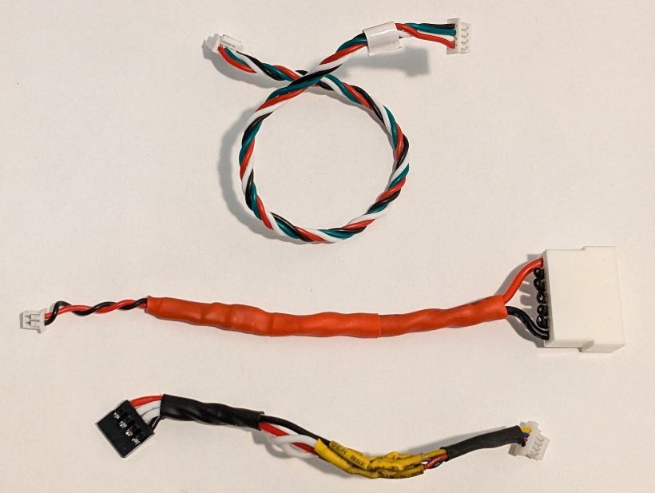

*Cables needed to connect PRM-03 telemetry module to CrossRace flight controller*

1. **Connect the flight controller’s TELEM1 port to the PRM**’s 4-pin RX/TX port with the provided cable. Secure extra length with a twist tie or cut and resolder to an appropriate length. *Top cable in photo above.*
2. **To connect the battery voltage port**, solder the provided 2-pin pigtail to the first and last leads on the 6S battery lead extension, respecting polarity. This will provide the telemetry module with the total battery voltage, as opposed to individual cell voltages. Reinforce this cable with extra heat shrink as the pigtail’s wires are quite thin. *Middle cable.*
3. **To connect the PRM-03 to the receiver**, use the 4-pin female header cable, and solder on a 4-pin JST-SH 1.0mm male plug to the other end, double checking which data wire goes where (SDA, SCA) before making connections and heat shrinking them. *Bottom cable.*
4. **Cables should be as short as needed**, and kept twisted to the extent possible in order to reduce interference on small data lines running next to high current motors. The telemetry module can be tucked into the drone’s chassis and secured with a patch of Velcro and a twist tie as backup.

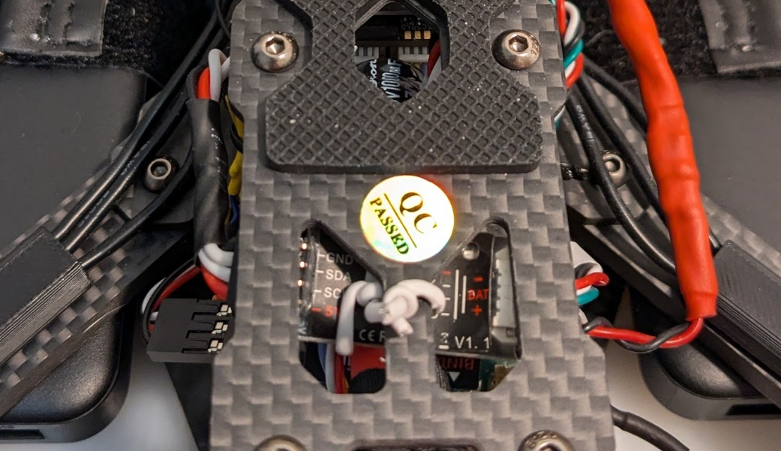

*PRM-03 installed at the rear of the airframe*

At this point, the drone and transmitter should be properly set up and ready to fly with live telemetry(battery voltage, roll/pitch/yaw, heading, and GPS data) provided to the transmitter. There is a great deal of customization possible with additional parameters (i.e. throttle curves for precision flying) or extra modules, should that be desired. Due to the intricacies of various flight controllers, Mission Planner parameters, and somewhat limited documentation available, those choices will be left to future users.

It is recommended to flight test the drone prior to payload installation in order to be sure that settings work as intended, and that flight is controllable when in proximity to objects being scanned.

## Payload Installation

The guiding principle for mounting important objects to fast moving things is redundancy ad nauseum. In the case of this proof of concept, the preferred order of operations is screws, zip ties, and Velcro to maximize solid points of contact, the ability to pre-tension and absorb stress, and relative speed of deployment. This is the area most ripe for improvements, and one where the addition of simple 3D printed brackets or bracing elements would see great benefits in reducing vibration and providing precise, repeatable positioning.

Before installation, consider the overall height of the payload, and whether additional clearance is needed. With the M435 drone and L1 LiDAR, 20mm M3 standoffs are added to increase the length of the landing legs such that the LiDAR has more than an inch of clearance on flat ground. Heat shrink is added to the front legs in order to aid orientation when in flight.

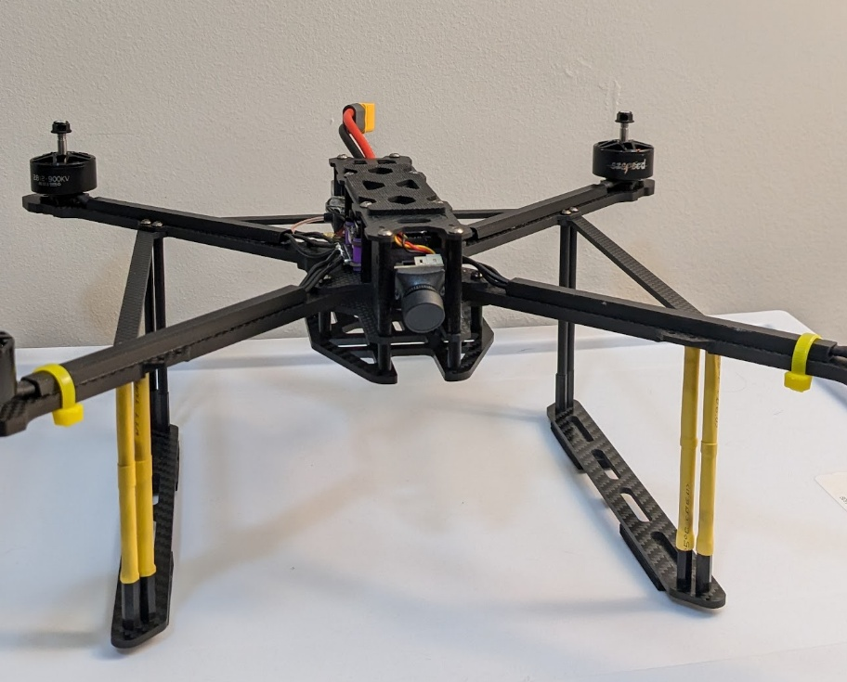

1. **Mount the 5V power packs** securely to the horizontal arms of the drone’s frame using a pair of straps from the drone kit. It is important that the straps be thread through the drone’s load plate and around the arms such that the metal of the strap is on the top side of the power pack. This way the payload can mount as flush as possible below them.

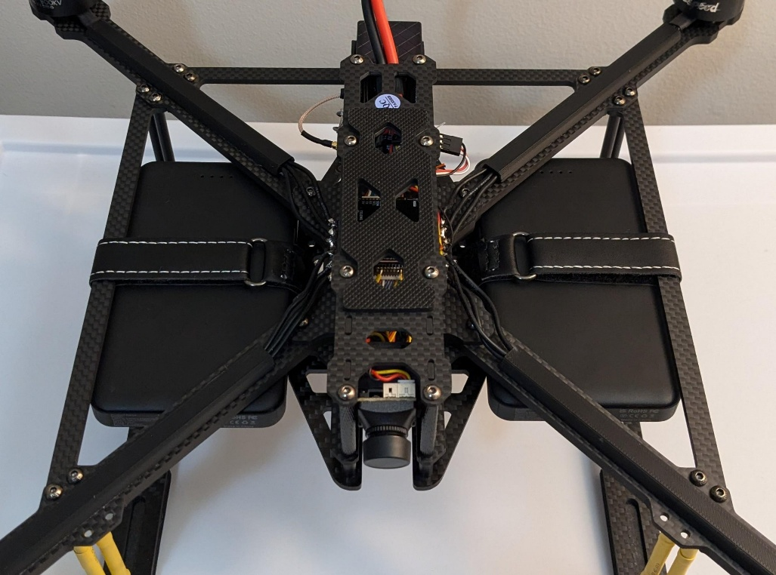

1. **Loosely attach payload with zip ties** through each of the four corner holes. Tighten opposite corners alternately to ensure the plate is as centered as possible, adjusting to also align the payload mounting holes in the slots as pictured above. Based on flexing, install appropriate standoffs and washers.

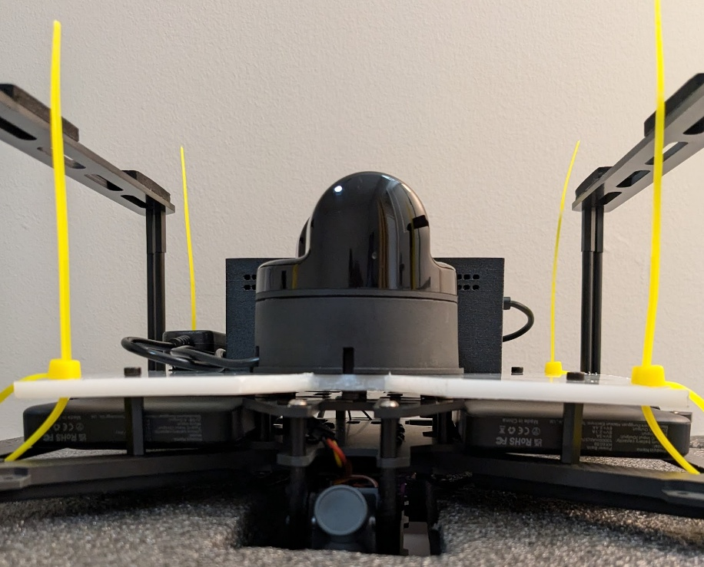

1. **Install payload mounting screws with washers** to secure HDPE plate to drone’s payload plate. Expedient washers were produced from scrap HDPE which provided multiple benefits: availability, reduced wear on power pack straps compared to metal washers, and post-tensioning of same straps to further lock power packs into place.

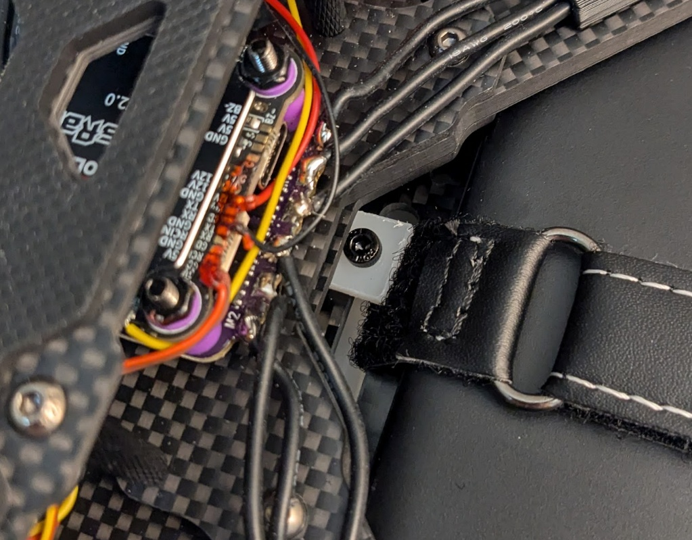

1. **Tighten zip ties to reasonable tension** and trim loose ends flush to avoid snags. Route cables and install zip tie on enclosure (optionally using the zip tie to further secure cable routing) to provide secondary means of attachment. The LiDAR is considered secure with screws since the mounting holes are threaded directly into the unit, and HPDE is unlikely to fail or allow the screws to pull through during normal operation.

## Data Collection

*Drone flights should be performed in accordance with all federal, state, and local laws. If in doubt, consult with local authorities and/or a legal representative.*

As configured, the M435 has a loaded flight time of about 15 minutes, but that was not verified with any endurance testing. Flight time will vary depending on the size of the site, but a casual walking speed provides enough point density for larger objects and surfaces to give models workable detail.

A pre-flight checklist is provided below to assist in data collection startup:

1. **Install propellers**, respecting the rotation direction of the motors.
2. **Install and secure payload** ensuring to route wires clear of the propellers.
3. **Clear debris from the launch area** to prevent anything striking the LiDAR or propellers on takeoff/landing.
4. **Mount LiPo battery** on top of drone with straps, but ***do not plug it in yet***
5. **Turn on transmitter** and confirm switches are in ‘SAFE’ position, SwA is down (motors disarmed), Flight Attitude set to Stabilize (or other non-GPS).
6. **Power LiDAR on** and confirm spinning with LEDs to indicate scanning.
7. **Power Raspberry Pi on** and perform following steps during startup (1 min).
8. **Verify propeller clearance** and cable routing, ensure launch area is clear.
9. **Plug in LiPo** to power the drone on. Once startup is complete, flip SwG to start the 10 and 15 minute timers to help track flight time and battery status.
10. **Arm motors with SwA** and begin data collection, keeping the drone level and pointing toward the object/area of interest, moving at a walking pace to achieve best results. Telemetry can be used to track battery levels and timers can be adjusted to reflect programmed scan time.

## Data Processing

Offloading data from the Raspberry Pi is as simple as plugging in a flash drive and copying the .las (and/or .pcd, point cloud) files to a computer for upload to ArcGIS. While the data conversion from .pcd to .las is handled easily by the RPi, and theoretically the datasets could be uploaded using a Wi-Fi enabled RPi, it’s best to use a PC with a graphics card to view and interact with large point clouds. ArcGIS natively accepts the .las files, and uploading them is a simple drag and drop operation.

The best way we found to display the point clouds within ArcGIS was to use a 3D Local Scene. After opening ArcGIS Pro, create a local scene. Use the “Add Data” tool to select the LAS file from your computer and add it to the scene.

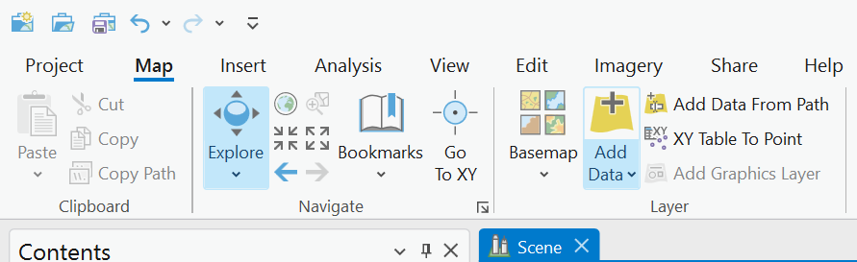

The LiDAR model should be interpreted automatically as a LiDAR point cloud and will appear in the scene in 3D. Make sure it is a local scene and not a standard map or global scene. In order to position it properly, the model will need to be scaled and translated to be properly placed within its geographic placement.



Once uploaded to ArcGIS and turned into a model, positioning can be done using an existing photogrammetry model and any defining features of the point cloud as a reference. Unfortunately the M435 doesn’t provide accurate enough GPS coordinates when it records flight data, and there’s no real way to link the point cloud to GPS data in-flight. This is an area for improvement, and one where a combined photogrammetry/LiDAR payload would be of great benefit.

# Section III – Improvements

While the processes described above will yield very functional results, it is primarily a proof of concept for an off-the-shelf photogrammetry and LiDAR scanning system that outputs easily integrated 3D models. Given that a large enough budget can make the problems of this project trivial, the development cycle identified a few areas as ripe for improvement within the limits already established. Among these are streamlining LiDAR data collection, improvements to the drone/payload design, and providing base stations for georeferencing.

During our tests over water for the dams, we found that the model has a difficult time producing accurate surfaces over the water due to its inconsistent visual components. Structures that were still visible and consistent below the surface stitched well and produced accurate results, but the water itself did not do very well. This was an instance where the point cloud was more accurate than the mesh model, as the point cloud helped mitigate the coarse stitching by throwing out portions of the model that were irregular.

Ground control points were something that was targeted but were not included as part of the final design due to time and resource constraints. The project is going to be continued this summer by a VCU undergraduate research project that will add more of this functionality and understanding to this project, but was not something that was integrated into any of the models produced during the course of this project. GCPs would add very accurate geolocation data to ensure the models are placed in the exact location through corrected GPS coordinates.

On the LiDAR drone, some improvements that could be made would involve the interface for starting and stopping the LiDAR collection process, providing an interface for seeing or controlling the collection during flight, and automated flight processes. These attributes would have been helpful additions but fell outside of the scope of designing a proof of concept that worked and was feasible within our time constraints. This implementation would probably require buttons and networking or radio communication between the drone and a controlling device.

An additional improvement would be to provide a more vibration-dampening mount for the LiDAR, or use the manufacturer’s recommended method for reducing severity of oscillation – mounting a US quarter to the side of the sensor. The drone, while capable of keeping steady position for the most part, was not easy to take off or land due to the constant wobbling induced by the LiDAR. While a way to remotely control the scanning of the LiDAR as discussed above would also be a means of correcting this issue, a mount that better addresses the oscillations or even allows the sensor to extend below the landing legs would be of great benefit to scan fidelity.